|  |  |
| --- | --- |
| INternet of things  Complete Notes | SAVE AND SHARE WITH YOUR CONNECTIONS TO HELP THEM  **Created by:- Bhabani Shankar Pradhan**  (Linkedin) <https://www.linkedin.com/in/bhabanishankarpradhan07/> |

# Contents

Introduction to Internet of Things 1

1. Introduction to Internet of Things 1
   1. Internet of Things . . . . . . . . . . . . . . . . . . . . . . . . . . 1
   2. What is Internet of Things? . . . . . . . . . . . . . . . . . . . . . 1
   3. Characteristics of IoT . . . . . . . . . . . . . . . . . . . . . . . . 1
   4. Physical Design of IoT . . . . . . . . . . . . . . . . . . . . . . . 2
      1. Things in IoT . . . . . . . . . . . . . . . . . . . . . . . . 2
      2. Iot Protocols . . . . . . . . . . . . . . . . . . . . . . . . 3
   5. Logical Design of IoT . . . . . . . . . . . . . . . . . . . . . . . . 5
      1. IoT Functional Blocks . . . . . . . . . . . . . . . . . . . 6
      2. IoT Communication Models . . . . . . . . . . . . . . . . 7
      3. IoT Communication APIs . . . . . . . . . . . . . . . . . 10
   6. IoT Enabling Technologies . . . . . . . . . . . . . . . . . . . . . 12
      1. Wireless Sensor Network(WSN): . . . . . . . . . . . . . 12
      2. Cloud Computing: . . . . . . . . . . . . . . . . . . . . . 13
      3. Big Data Analytics: . . . . . . . . . . . . . . . . . . . . . 13
      4. Communication Protocols: . . . . . . . . . . . . . . . . . 14
      5. Embedded Systems: . . . . . . . . . . . . . . . . . . . . 14
   7. IoT Levels and Deployment Templates . . . . . . . . . . . . . . . 14
      1. IoT Level-1 . . . . . . . . . . . . . . . . . . . . . . . . . 14
      2. IoT Level-2 . . . . . . . . . . . . . . . . . . . . . . . . . 15
      3. IoT Level-3 . . . . . . . . . . . . . . . . . . . . . . . . . 16
      4. IoT Level-4 . . . . . . . . . . . . . . . . . . . . . . . . . 17
      5. IoT Level-5 . . . . . . . . . . . . . . . . . . . . . . . . . 18
      6. IoT Level-6 . . . . . . . . . . . . . . . . . . . . . . . . . 19
   8. Layered Architecture: . . . . . . . . . . . . . . . . . . . . . . . . 19
   9. IoT and M2M . . . . . . . . . . . . . . . . . . . . . . . . . . . . 20
      1. M2M: . . . . . . . . . . . . . . . . . . . . . . . . . . . . 20
   10. Differences between IoT and M2M . . . . . . . . . . . . . . . . 22

Introduction to Internet of Things

1. Domain Specific IoTs 23
   1. Home Automation: . . . . . . . . . . . . . . . . . . . . . . . . . 23
   2. Cities: . . . . . . . . . . . . . . . . . . . . . . . . . . . . . . . . 23
   3. Environment: . . . . . . . . . . . . . . . . . . . . . . . . . . . . 24
   4. Energy: . . . . . . . . . . . . . . . . . . . . . . . . . . . . . . . 25
2. Elements of IoT 27
   1. Hardware Components . . . . . . . . . . . . . . . . . . . . . . . 27
      1. Basic Building Blocks of IoT Devices . . . . . . . . . . . 27
      2. Raspberry Pi . . . . . . . . . . . . . . . . . . . . . . . . 27
      3. Raspberry Pi Interfaces . . . . . . . . . . . . . . . . . . . 31
      4. Arduino . . . . . . . . . . . . . . . . . . . . . . . . . . . 33
3. IoT Application Development 39
   1. Introduction . . . . . . . . . . . . . . . . . . . . . . . . . . . . . 39
   2. Framework . . . . . . . . . . . . . . . . . . . . . . . . . . . . . 39
   3. Solution for IoT Application . . . . . . . . . . . . . . . . . . . . 39
   4. Web Application in Python . . . . . . . . . . . . . . . . . . . . . 40
      1. Flask . . . . . . . . . . . . . . . . . . . . . . . . . . . . 40
      2. Django . . . . . . . . . . . . . . . . . . . . . . . . . . . 58
   5. Data acquisition, Storage and Integration in IoT Framework . . . 86

Ranjit Patnaik ii

# List of Tables

4.1 List of options for app.run() . . . . . . . . . . . . . . . . . . . . . 42

4.2 List of HTTP responses in flask. . . . . . . . . . . . . . . . . . . 45

4.3 Commonly used fields and their details . . . . . . . . . . . . . . . 74

# List of Figures

|  |  |
| --- | --- |
| 1.1 Generic Block Diagram of IoT Devices. . . . . . . . . . . . . . . | 2 |
| 1.2 Protocols in IoT. . . . . . . . . . . . . . . . . . . . . . . . . . . . | 3 |
| 1.3 IoT Functional Blocks . . . . . . . . . . . . . . . . . . . . . . . | 6 |
| 1.4 Request-Response Model . . . . . . . . . . . . . . . . . . . . . . | 7 |
| 1.5 Publish-Subscribe Model . . . . . . . . . . . . . . . . . . . . . . | 8 |
| 1.6 Push-Pull Model . . . . . . . . . . . . . . . . . . . . . . . . . . | 9 |
| 1.7 Exclusive Pair Model . . . . . . . . . . . . . . . . . . . . . . . . | 9 |
| 1.8 REST-based Communication API. . . . . . . . . . . . . . . . . . | 11 |
| 1.9 Web-based Communication API. . . . . . . . . . . . . . . . . . . | 12 |
| 1.10 Block Diagram of IoT Level 1. . . . . . . . . . . . . . . . . . . . | 15 |
| 1.11 Block Diagram of IoT Level 2. . . . . . . . . . . . . . . . . . . . | 16 |
| 1.12 Block Diagram of IoT Level 3. . . . . . . . . . . . . . . . . . . . | 17 |
| 1.13 Block Diagram of IoT Level 4. . . . . . . . . . . . . . . . . . . . | 18 |
| 1.14 Block Diagram of IoT Level 5. . . . . . . . . . . . . . . . . . . . | 18 |
| 1.15 Block Diagram of IoT Level 6. . . . . . . . . . . . . . . . . . . . | 19 |
| 1.16 Architecture of IoT (A: three layers) (B: five layers). . . . . . . . | 20 |
| 1.17 M2M Architecture. . . . . . . . . . . . . . . . . . . . . . . . . . | 21 |
| 1.18 M2M Network. . . . . . . . . . . . . . . . . . . . . . . . . . . . | 21 |
| 3.1 Raspberry Pi Model 3B. . . . . . . . . . . . . . . . . . . . . . . | 28 |
| 3.2 Raspberry Pi Model 3B Block Diagram. . . . . . . . . . . . . . . | 29 |
| 3.3 Raspberry Pi Model 3B Pin Diagram. . . . . . . . . . . . . . . . | 30 |
| 3.4 Raspberry Pi Model 3B GPIO Pin Logical Numbers. . . . . . . . | 32 |
| 3.5 Arduino Uno board . . . . . . . . . . . . . . . . . . . . . . . . . | 34 |
| 3.6 Arduino Uno board . . . . . . . . . . . . . . . . . . . . . . . . . | 35 |
| 3.7 Arduino Uno board interfacing DHT sensor. . . . . . . . . . . . . | 36 |
| 3.8 Arduino Uno board interfacing Ultrasonic sensor. . . . . . . . . . | 37 |
| 3.9 Arduino Uno board interfacing 16 X 2 LCD Display. . . . . . . . | 38 |
| 4.1 Output of the script.py . . . . . . . . . . . . . . . . . . . . . . . | 41 |
| 4.2 Output of the script.py on the browser. . . . . . . . . . . . . . . . | 42 |

Introduction to Internet of Things

|  |  |
| --- | --- |
| 4.3 MVT Architecture of Django. . . . . . . . . . . . . . . . . . . . | 61 |
| 4.4 Django Server Running output. . . . . . . . . . . . . . . . . . . . | 63 |
| 4.5 Django Image Loading Example. . . . . . . . . . . . . . . . . . . | 68 |
| 4.6 Django JScript Loading Example. . . . . . . . . . . . . . . . . . | 69 |
| 4.7 CSS file Loading Example. . . . . . . . . . . . . . . . . . . . . . | 70 |
| 4.8 Django Model Form output. . . . . . . . . . . . . . . . . . . . . | 72 |
| 4.9 Django Model Form output. . . . . . . . . . . . . . . . . . . . . | 75 |
| 4.10 Django Model Form validation. . . . . . . . . . . . . . . . . . . . | 77 |
| 4.11 Django Model Form after validation. . . . . . . . . . . . . . . . . | 78 |
| 4.12 Django File uploading application. . . . . . . . . . . . . . . . . . | 80 |
| 4.13 Database structure for the project. . . . . . . . . . . . . . . . . . | 81 |
| 4.14 Database structure for the project includes the table. . . . . . . . . | 82 |
| 4.15 Admin login panel. . . . . . . . . . . . . . . . . . . . . . . . . . | 84 |
| 4.16 Admin login Credential. . . . . . . . . . . . . . . . . . . . . . . | 84 |
| 4.17 Admin Dashboard login. . . . . . . . . . . . . . . . . . . . . . . | 85 |
| 4.18 Admin login Dashboard after adding the table in the database. . . | 86 |

Ranjit Patnaik vi

# Listings

|  |  |
| --- | --- |
| 3.1 LED.py . . . . . . . . . . . . . . . . . . . . . . . . . . . . . . . | 32 |
| 3.2 Button.py . . . . . . . . . . . . . . . . . . . . . . . . . . . . . . | 33 |
| 3.3 LED with Button.py . . . . . . . . . . . . . . . . . . . . . . . . . | 33 |
| 3.4 DHT11.ino . . . . . . . . . . . . . . . . . . . . . . . . . . . . . | 35 |
| 3.5 Ultrasonic.ino . . . . . . . . . . . . . . . . . . . . . . . . . . . . | 36 |
| 3.6 16 X 2 LCD.ino . . . . . . . . . . . . . . . . . . . . . . . . . . . | 37 |
| 4.1 First Flask Example. . . . . . . . . . . . . . . . . . . . . . . . . | 41 |
| 4.2 Variable Rule Example for different types variable. . . . . . . . . | 43 |
| 4.3 Variable Rule example. . . . . . . . . . . . . . . . . . . . . . . . | 44 |
| 4.4 Variable Rule for integer and float example. . . . . . . . . . . . . | 44 |
| 4.5 Werkzeug’s routing example. . . . . . . . . . . . . . . . . . . . . | 44 |
| 4.6 login.html for HTTP REsponce . . . . . . . . . . . . . . . . . . . | 46 |
| 4.7 login.py for HTTP Responce . . . . . . . . . . . . . . . . . . . . | 46 |
| 4.8 Template for HTTP Responce without HTML file. . . . . . . . . . | 47 |
| 4.9 Template for HTTP Responce with HTML file. . . . . . . . . . . | 47 |
| 4.10 First Templates Example(Html file). . . . . . . . . . . . . . . . . | 48 |
| 4.11 First Templates ExamplePython file). . . . . . . . . . . . . . . . . | 48 |
| f.py . . . . . . . . . . . . . . . . . . . . . . . . . . . . . . . . . . . . | 49 |
| f.html . . . . . . . . . . . . . . . . . . . . . . . . . . . . . . . . . . . | 49 |
| fo.py . . . . . . . . . . . . . . . . . . . . . . . . . . . . . . . . . . . . | 50 |
| s.html . . . . . . . . . . . . . . . . . . . . . . . . . . . . . . . . . . . | 50 |
| r.html . . . . . . . . . . . . . . . . . . . . . . . . . . . . . . . . . . . | 51 |
| coockie.py . . . . . . . . . . . . . . . . . . . . . . . . . . . . . . . . . | 51 |
| s.py . . . . . . . . . . . . . . . . . . . . . . . . . . . . . . . . . . . . | 52 |
| s1.html . . . . . . . . . . . . . . . . . . . . . . . . . . . . . . . . . . . | 53 |
| upload.py . . . . . . . . . . . . . . . . . . . . . . . . . . . . . . . . . | 53 |
| file upload form.html . . . . . . . . . . . . . . . . . . . . . . . . . . . | 54 |
| success.html . . . . . . . . . . . . . . . . . . . . . . . . . . . . . . . . | 54 |
| EmoloyeeDB.py . . . . . . . . . . . . . . . . . . . . . . . . . . . . . . | 54 |
| 4.12 Home Page UI. . . . . . . . . . . . . . . . . . . . . . . . . . . . | 56 |
| 4.13 Add employee UI. . . . . . . . . . . . . . . . . . . . . . . . . . . | 56 |

Introduction to Internet of Things

|  |  |
| --- | --- |
| 4.14 Delete employee UI. . . . . . . . . . . . . . . . . . . . . . . . . | 57 |
| 4.15 Viwe employee UI. . . . . . . . . . . . . . . . . . . . . . . . . . | 57 |
| d urls.py . . . . . . . . . . . . . . . . . . . . . . . . . . . . . . . . . . | 65 |
| 4.16 index.html . . . . . . . . . . . . . . . . . . . . . . . . . . . . . . | 67 |
| 4.17 urls.py . . . . . . . . . . . . . . . . . . . . . . . . . . . . . . . . | 67 |
| 4.18 views.py . . . . . . . . . . . . . . . . . . . . . . . . . . . . . . . | 67 |
| 4.19 index.html . . . . . . . . . . . . . . . . . . . . . . . . . . . . . . | 68 |
| 4.20 script.js . . . . . . . . . . . . . . . . . . . . . . . . . . . . . . . | 68 |
| 4.21 style.css . . . . . . . . . . . . . . . . . . . . . . . . . . . . . . . | 69 |
| 4.22 index.html . . . . . . . . . . . . . . . . . . . . . . . . . . . . . . | 69 |
| 4.23 model.py . . . . . . . . . . . . . . . . . . . . . . . . . . . . . . | 70 |
| 4.24 forms.py . . . . . . . . . . . . . . . . . . . . . . . . . . . . . . . | 71 |
| 4.25 views.py . . . . . . . . . . . . . . . . . . . . . . . . . . . . . . . | 71 |
| 4.26 urls.py . . . . . . . . . . . . . . . . . . . . . . . . . . . . . . . . | 71 |
| 4.27 index.html . . . . . . . . . . . . . . . . . . . . . . . . . . . . . . | 71 |
| 4.28 forms.py . . . . . . . . . . . . . . . . . . . . . . . . . . . . . . . | 73 |
| 4.29 views.py . . . . . . . . . . . . . . . . . . . . . . . . . . . . . . . | 74 |
| 4.30 index.html . . . . . . . . . . . . . . . . . . . . . . . . . . . . . . | 74 |
| 4.31 urls.py . . . . . . . . . . . . . . . . . . . . . . . . . . . . . . . . | 75 |
| 4.32 models.py . . . . . . . . . . . . . . . . . . . . . . . . . . . . . . | 76 |
| 4.33 forms.py . . . . . . . . . . . . . . . . . . . . . . . . . . . . . . . | 76 |
| 4.34 forms.py . . . . . . . . . . . . . . . . . . . . . . . . . . . . . . . | 76 |
| 4.35 index.html . . . . . . . . . . . . . . . . . . . . . . . . . . . . . . | 77 |
| 4.36 index.html . . . . . . . . . . . . . . . . . . . . . . . . . . . . . . | 78 |
| 4.37 forms.py . . . . . . . . . . . . . . . . . . . . . . . . . . . . . . . | 78 |
| 4.38 views.py . . . . . . . . . . . . . . . . . . . . . . . . . . . . . . . | 79 |
| 4.39 urls.py . . . . . . . . . . . . . . . . . . . . . . . . . . . . . . . . | 79 |
| 4.40 functions.py . . . . . . . . . . . . . . . . . . . . . . . . . . . . . | 80 |
| 4.41 Database confirguation in settings.py . . . . . . . . . . . . . . . . | 81 |
| 4.42 models.py . . . . . . . . . . . . . . . . . . . . . . . . . . . . . . | 82 |
| 4.43 Url Setting in urls.py for admin . . . . . . . . . . . . . . . . . . . | 83 |
| 4.44 Url Setting in urls.py for admin . . . . . . . . . . . . . . . . . . . | 84 |
| 4.45 admin.py . . . . . . . . . . . . . . . . . . . . . . . . . . . . . . | 85 |
| 4.46 models.py . . . . . . . . . . . . . . . . . . . . . . . . . . . . . . | 86 |
| 4.47 Python Script for Temprature Monitor Application. . . . . . . . . | 87 |
| 4.48 Home Page UI. . . . . . . . . . . . . . . . . . . . . . . . . . . . | 88 |
| 4.49 Storing Sensor data UI. . . . . . . . . . . . . . . . . . . . . . . . | 89 |
| 4.50 Fetch Temprature data from database UI. . . . . . . . . . . . . . .  4.51 Showing Current temprature reading from sensor UI(Data Inte- | 89 |
| gration). . . . . . . . . . . . . . . . . . . . . . . . . . . . . . . . | 90 |

Ranjit Patnaik 1

# Chapter 1

Introduction to Internet of Things

## 1.1 Internet of Things

Internet of Things (IoT) is the networking of physical objects that contain electronics embedded within their architecture in order to communicate and sense interactions amongst each other or with respect to the external environment. In the upcoming years, IoT-based technology will offer advanced levels of services and practically change the way people lead their daily lives. Advancements in medicine, power, gene therapies, agriculture, smart cities, and smart homes are just a very few of the categorical examples where IoT is strongly established.

Over 9 billion ‘Things’ (physical objects) are currently connected to the Internet, as of now. In the near future, this number is expected to rise to a whopping 20 billion.

1.2 What is Internet of Things?

The Internet of thing is defined as a network of physical or things that are embedded with software, electronics, network and sensors which allows these objects to collect and exchange data.

## 1.3 Characteristics of IoT

1. Dynamic and Self-Adapting: The IoT devices and system may have the capability to dynamically adopt the changing context of it’s environment.
2. Self-Configuring: The IoT devices may have capability of self-configuring, which allows a large number of devices to work together to provide certain functionality.
3. Inter-operable Communication Protocols:
4. Unique Identity:
5. Integrated into Information Network:

## 1.4 Physical Design of IoT

The physical design of IoT is based on the following components:

1. Things in IoT
2. Iot Protocols

### 1.4.1 Things in IoT

Things refers to the objects in the IoT environment. The devices are in IoT is known as objects. The devices collects the data and exchanges with other devices connected in the network either directly or indirectly.

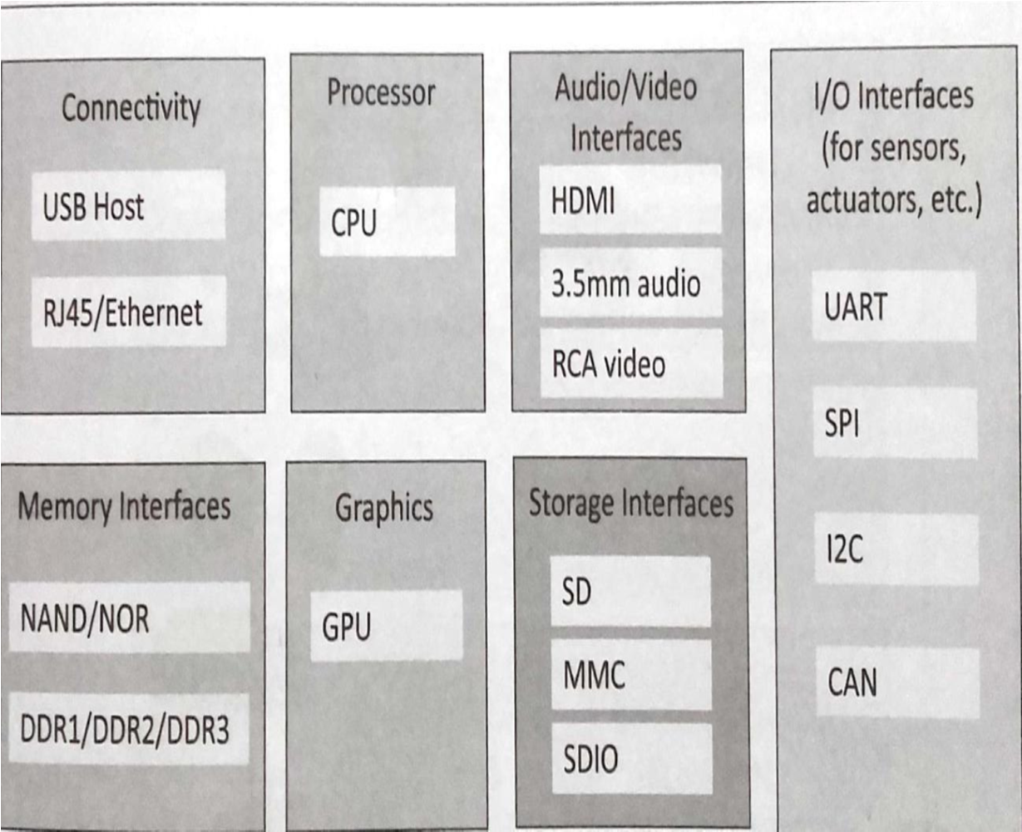

Figure 1.1: Generic Block Diagram of IoT Devices.

An IoT device may consist of several interfaces for communication to other devices both wired and wireless. These includes (i) I/O interfaces for sensors, (ii) Interfaces for internet connectivity (iii) memory and storage interfaces and (iv) audio/video interfaces.

### 1.4.2 Iot Protocols

∗ Link Layer : Protocols determine how data is physically sent over the network‘s physical layer or medium. Local network connect to which host is attached. Hosts on the same link exchange data packets over the link layer using link layer protocols. Link layer determines how packets are coded and signaled by the h/w device over the medium to which the host is attached.

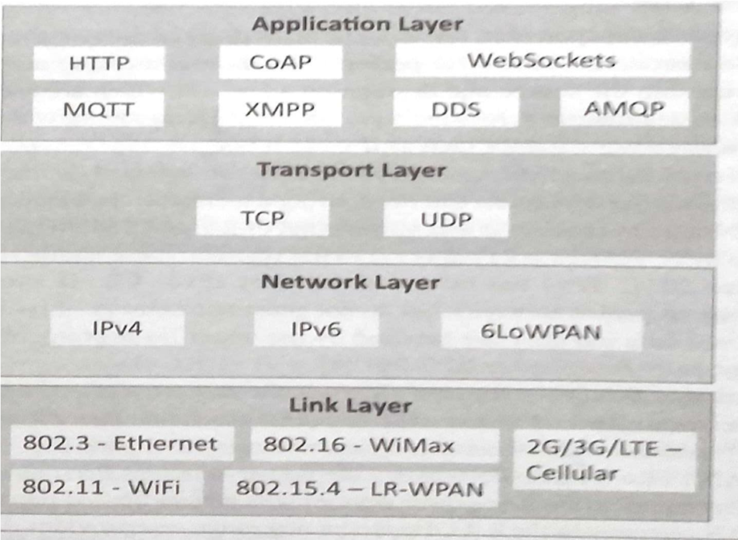

Figure 1.2: Protocols in IoT.

Protocols:

* 802.3-Ethernet: IEEE802.3 is collection of wired Ethernet standards for the link layer. Eg: 802.3 uses co-axial cable; 802.3i uses copper twisted pair connection; 802.3j uses fiber optic connection; 802.3ae uses Ethernet over fiber.
* 802.11-WiFi: IEEE802.11 is a collection of wireless LAN(WLAN) communication standards including extensive description of link layer. Eg: 802.11a operates in 5GHz band, 802.11b and 802.11g operates in

2.4GHz band, 802.11n operates in 2.4/5GHz band, 802.11ac operates in 5GHz band, 802.11ad operates in 60Ghz band.

* 802.16 - WiMax: IEEE802.16 is a collection of wireless broadband standards including exclusive description of link layer. WiMax provide data rates from 1.5 Mb/s to 1Gb/s.
* 802.15.4-LR-WPAN: IEEE802.15.4 is a collection of standards for low rate wireless personal area network(LR-WPAN). Basis for high level communication protocols such as ZigBee. Provides data rate from 40kb/s to250kb/s.
* 2G/3G/4G-Mobile Communication: Data rates from 9.6kb/s(2G) to up to100Mb/s(4G).

∗ Network/Internet Layer: Responsible for sending IP datagrams from source n/w to destination n/w. Performs the host addressing and packet routing. Datagrams contains source and destination address.

Protocols:

* IPv4: Internet Protocol version4 is used to identify the devices on a n/w using a hierarchical addressing scheme. 32 bit address. Allows total of 2**32addresses.
* IPv6: Internet Protocol version6 uses 128 bit address scheme and allows 2**128 addresses.
* 6LOWPAN:(IPv6over Lowpower Wireless Personal Area Network) operates in 2.4 GHz frequency range and data transfer 250 kb/s.

∗ Transport Layer: Provides end-to-end message transfer capability independent of the underlying n/w. Set up on connection with ACK as in TCP and without ACK as in UDP. Provides functions such as error control, segmentation, flow control and congestion control.

Protocols:

* TCP: Transmission Control Protocol used by web browsers(along with HTTP and HTTPS), email(along with SMTP, FTP). Connection oriented and stateless protocol. IP Protocol deals with sending packets, TCP ensures reliable transmission of protocols in order. Avoids n/w congestion and congestion collapse.
* UDP: User Datagram Protocol is connectionless protocol. Useful in time sensitive applications, very small data units to exchange. Transaction oriented and stateless protocol. Does not provide guaranteed delivery.

∗ Application Layer: Defines how the applications interface with lower layer protocols to send data over the n/w. Enables process-to-process communication using ports.

Protocols:

* HTTP: Hyper Text Transfer Protocol that forms foundation of WWW. Follow request-response model Stateless protocol.
* CoAP: Constrained Application Protocol for machine-to-machine(M2M) applications with constrained devices, constrained environment and constrained n/w. Uses client-server architecture.
* WebSocket: allows full duplex communication over a single socket connection.
* MQTT: Message Queue Telemetry Transport is light weight messaging protocol based on publish-subscribe model. Uses client server architecture. Well suited for constrained environment.
* XMPP: Extensible Message and Presence Protocol for real time communication and streaming XML data between network entities. Support client-server and server-server communication.
* DDS: Data Distribution Service is data centric middleware standards for device-to-device or machine-to-machine communication. Uses publishsubscribe model.
* AMQP: Advanced Message Queuing Protocol is open application layer protocol for business messaging. Supports both point-to-point and publish-subscribe model.

## 1.5 Logical Design of IoT

Logical design of IoT system refers to an abstract representation of the entities and processes without going into the low-level specifies of the implementation. For understanding Logical Design of IoT, we describes given below terms.

1. IoT Functional Blocks
2. IoT Communication Models
3. IoT Communication APIs

### 1.5.1 IoT Functional Blocks

An IoT system comprises of a number of functional blocks that provide the system the capabilities for identification, sensing, actuation, communication and management. functional blocks are:

* Device: An IoT system comprises of devices that provide sensing, actuation, monitoring and control functions.
* Communication: Handles the communication for the IoT system.
* Services: services for device monitoring, device control service, data publishing services and services for device discovery.
* Management: this blocks provides various functions to govern the IoT system.
* Security: this block secures the IoT system and by providing functions such as authentication , authorization, message and content integrity, and data security.
* Application: This is an interface that the users can use to control and monitor various aspects of the IoT system. Application also allow users to view the system status and view or analyze the processed data.

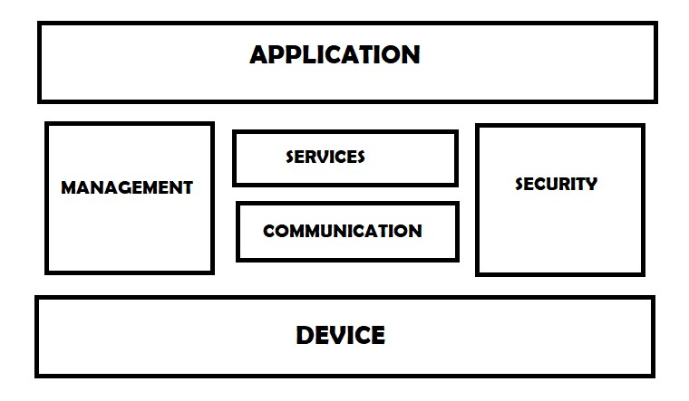

Figure 1.3: IoT Functional Blocks

### 1.5.2 IoT Communication Models

There four types of the communication models in IoT such as:

1. Request-Response Model
2. Publish-Subscribe Model
3. Push-Pull Model
4. Exclusive Pair Model

#### Request-Response Model

Request-Response Model Request-response model is communication model in which the client sends requests to the server and the server responds to the requests. When the server receives a request, it decides how to respond, fetches the data, retrieves resource representation, prepares the response, and then sends the response to the client. Request-response is a stateless communication model and each request-response pair is independent of others.

HTTP works as a request-response protocol between a client and server. A web browser may be the client, and an application on a computer that hosts a web site may be the server.

Example: A client (browser) submits an HTTP request to the server; then the server returns a response to the client. The response contains status information about the request and may also contain the requested content.

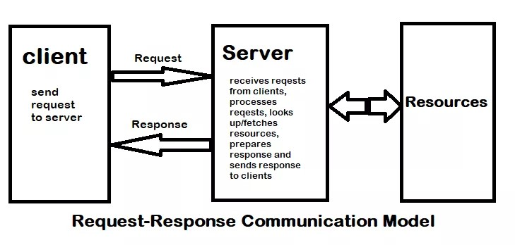

Figure 1.4: Request-Response Model

#### Publish-Subscribe Model

Publish-Subscribe is a communication model that involves publishers, brokers and consumers. Publishers are the source of data. Publishers send the data to the topics which are managed by the broker. Publishers are not aware of the consumers. Consumers subscribe to the topics which are managed by the broker. When the broker receive data for a topic from the publisher, it sends the data to all the subscribed consumers.

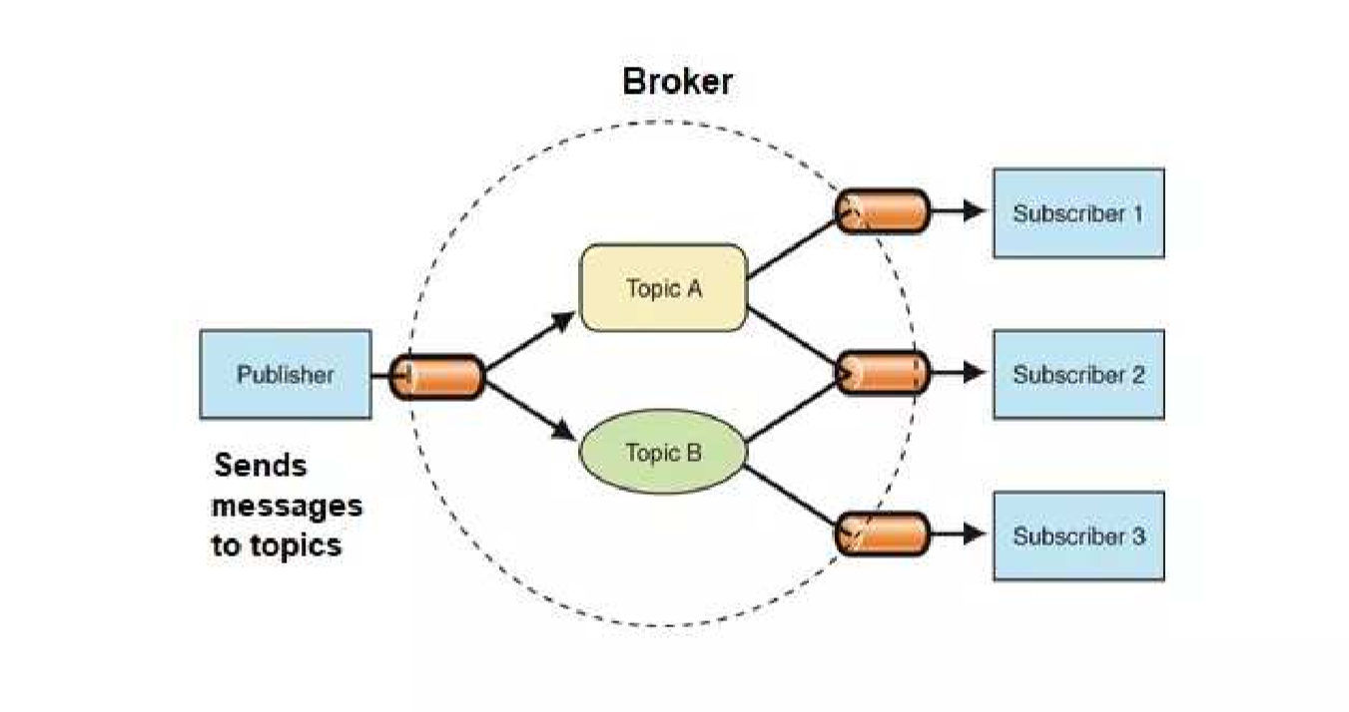

Figure 1.5: Publish-Subscribe Model

#### Push-Pull Model

Push-Pull is a communication model in which the data producers push the data to queues and the consumers Pull the data from the Queues. Producers do not need to be aware of the consumers. Queues help in decoupling the messaging between the Producers and Consumers. Queues also act as a buffer which helps in situations when there is a mismatch between the rate at which the producers push data and the rate rate at which the consumer pull data.

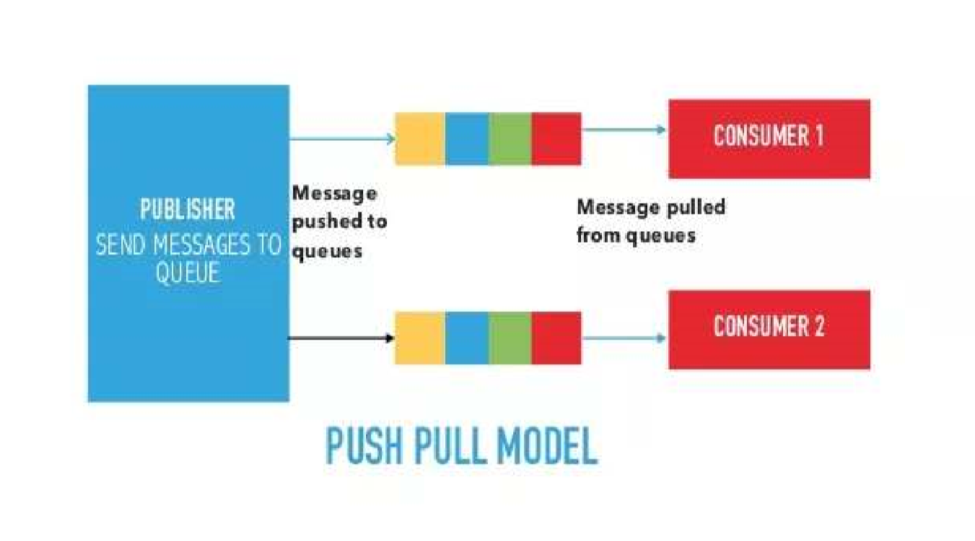

Figure 1.6: Push-Pull Model

#### Exclusive Pair Model

Exclusive Pair is a bidirectional, fully duplex communication model that uses a persistent connection between the client and server. Connection is setup it remains open until the client sends a request to close the connection. Client and server can send messages to each other after connection setup. Exclusive pair is stateful communication model and the server is aware of all the open connections.

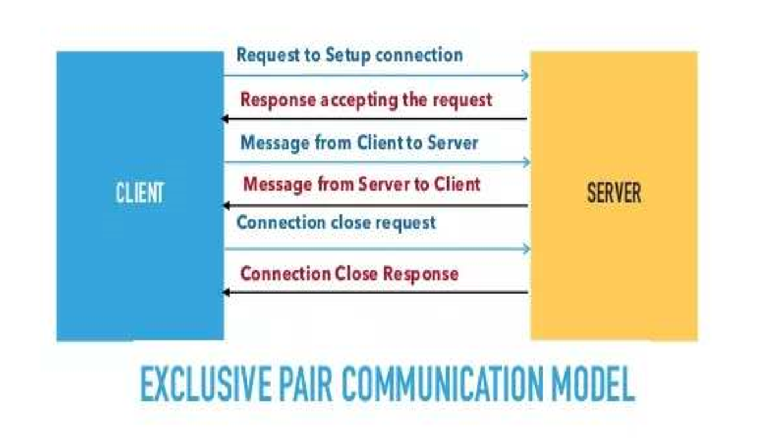

Figure 1.7: Exclusive Pair Model

### 1.5.3 IoT Communication APIs

Generally we used Two APIs For IoT Communication. These IoT Communication APIs are:

* REST-based Communication APIs
* WebSocket-based Communication APIs

#### REST-based Communication APIs

Representational state transfer (REST) is a set of architectural principles by which you can design Web services the Web APIs that focus on systems’s resources and how resource states are addressed and transferred. REST APIs that follow the request response communication model, the rest architectural constraint apply to the components, connector and data elements, within a distributed hypermedia system. The rest architectural constraint are as follows:

* Client-server – The principle behind the client-server constraint is the separation of concerns. for example clients should not be concerned with the storage of data which is concern of the serve. Similarly the server should not be concerned about the user interface, which is concern of the clien. Separation allows client and server to be independently developed and updated.
* Stateless – Each request from client to server must contain all the information necessary to understand the request, and cannot take advantage of any stored context on the server. The session state is kept entirely on the client.
* Cache-able – Cache constraints requires that the data within a response to a request be implicitly or explicitly leveled as cache-able or non cache-able. If a response is cache-able, then a client cache is given the right to reuse that repsonse data for later, equivalent requests. caching can partially or completely eliminate some instructions and improve efficiency and scalability.
* Layered system – layered system constraints, constrains the behavior of components such that each component cannot see beyond the immediate layer with they are interacting. For example, the client cannot tell whether it is connected directly to the end server or two an intermediaryalong the way. System scalability can be improved by allowing intermediaries to respond to requests instead of the end server, without the client having to do anything different.
* Uniform interface – uniform interface constraints requires that the method of communication between client and server must be uniform. Resources are identified in the requests (by URIsin web based systems) and are themselves is separate from the representations of the resources data returned to the client. When a client holds a representation of resources it has all the information required to update or delete the resource you (provided the client has required permissions). Each message includes enough information to describe how to process the message.
* Code on demand – Servers can provide executable code or scripts for clients to execute in their context. this constraint is the only one that is optional.

A RESTful web service is a ”Web API ” implemented using HTTP and REST principles. REST is most popular IoT Communication APIs.

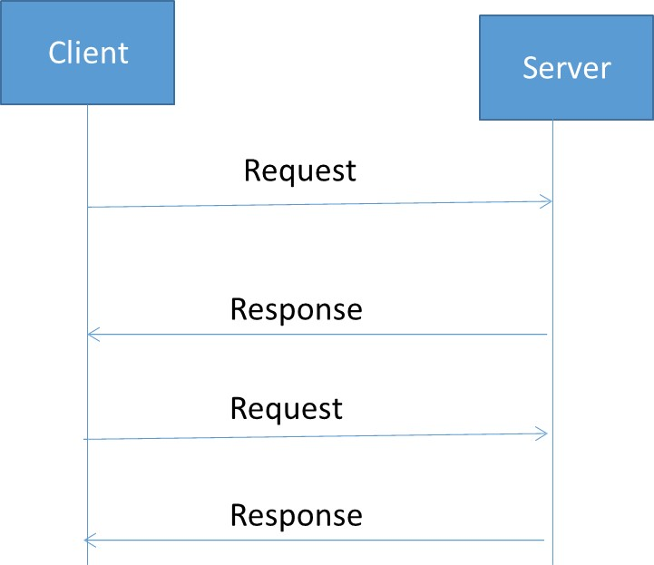

Figure 1.8: REST-based Communication API.

#### WebSocket-based Communication APIs

WebSocket APIs allow bi-directional, full duplex communication between clients and servers. WebSocket APIs follow the exclusive pair communication model.

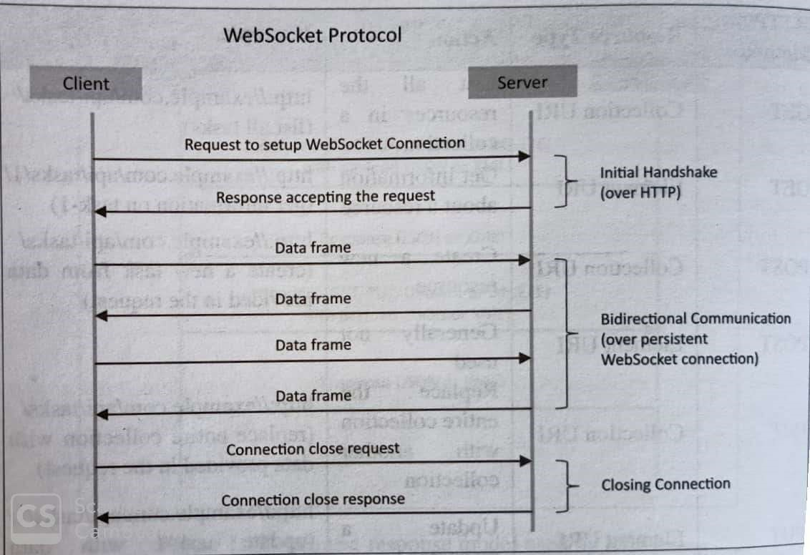

Figure 1.9: Web-based Communication API.

## 1.6 IoT Enabling Technologies

IoT is enabled by several technologies including Wireless Sensor Networks, Cloud Computing, Big Data Analytics, Embedded Systems, Security Protocols and architectures, Communication Protocols, Web Services, Mobile internet and semantic search engines.

1.6.1 Wireless Sensor Network(WSN):

Comprises of distributed devices with sensors which are used to monitor the environmental and physical conditions. Zig Bee is one of the most popular wireless technologies used byWSNs. WSNs used in IoT systems are described as follows:

1. Weather Monitoring System: in which nodes collect temp, humidity and other data, which is aggregated and analyzed.
2. Indoor air quality monitoring systems: to collect data on the indoor air quality and concentration of various gases.
3. Soil Moisture Monitoring Systems: to monitor soil moisture at various locations.
4. Surveillance Systems: use WSNs for collecting surveillance data(motion data detection).
5. Smart Grids : use WSNs for monitoring grids at various points.
6. Structural Health Monitoring Systems: Use WSNs to monitor the health of structures(building, bridges) by collecting vibrations from sensor nodes deployed at various points in the structure.

1.6.2 Cloud Computing:

Services are offered to users in different forms.

1. Infrastructure-as-a-service(IaaS):provides users the ability to provision computing and storage resources. These resources are provided to the users as a virtual machine instances and virtual storage.
2. Platform-as-a-Service(PaaS): provides users the ability to develop and deploy application in cloud using the development tools, APIs, software libraries and services provided by the cloud service provider.
3. Software-as-a-Service(SaaS): provides the user a complete software application or the user interface to the application itself.

1.6.3 Big Data Analytics:

Some examples of big data generated by IoT are

1. Sensor data generated by IoT systems.
2. Machine sensor data collected from sensors established in industrial and energy systems.
3. Health and fitness data generated IoT devices.
4. Data generated by IoT systems for location and tracking vehicles.
5. Data generated by retail inventory monitoring systems.

1.6.4 Communication Protocols:

Form the back-bone of IoT systems and enable network connectivity and coupling to applications.

1. Allow devices to exchange data over network.
2. Define the exchange formats, data encoding addressing schemes for device and routing of packets from source to destination.
3. It includes sequence control, flow control and re-transmission of lost packets.

1.6.5 Embedded Systems:

Embedded Systems are a computer system that has computer hardware and software embedded to perform specific tasks. Embedded System range from low cost miniaturized devices such as digital watches to devices such as digital cameras, POS terminals, vending machines, appliances etc.,

## 1.7 IoT Levels and Deployment Templates

There are six types of IoT levels which are mentioned below:

1. IoT Level-1
2. IoT Level-2
3. IoT Level-3
4. IoT Level-4
5. IoT Level-5
6. IoT Level-6

### 1.7.1 IoT Level-1

System has a single node that performs sensing and/or actuation, stores data, performs analysis and host the application as shown in fig. Suitable for modeling low cost and low complexity solutions where the data involved is not big and analysis requirement are not computationally intensive. An e.g., of IoT Level1 is Home automation.

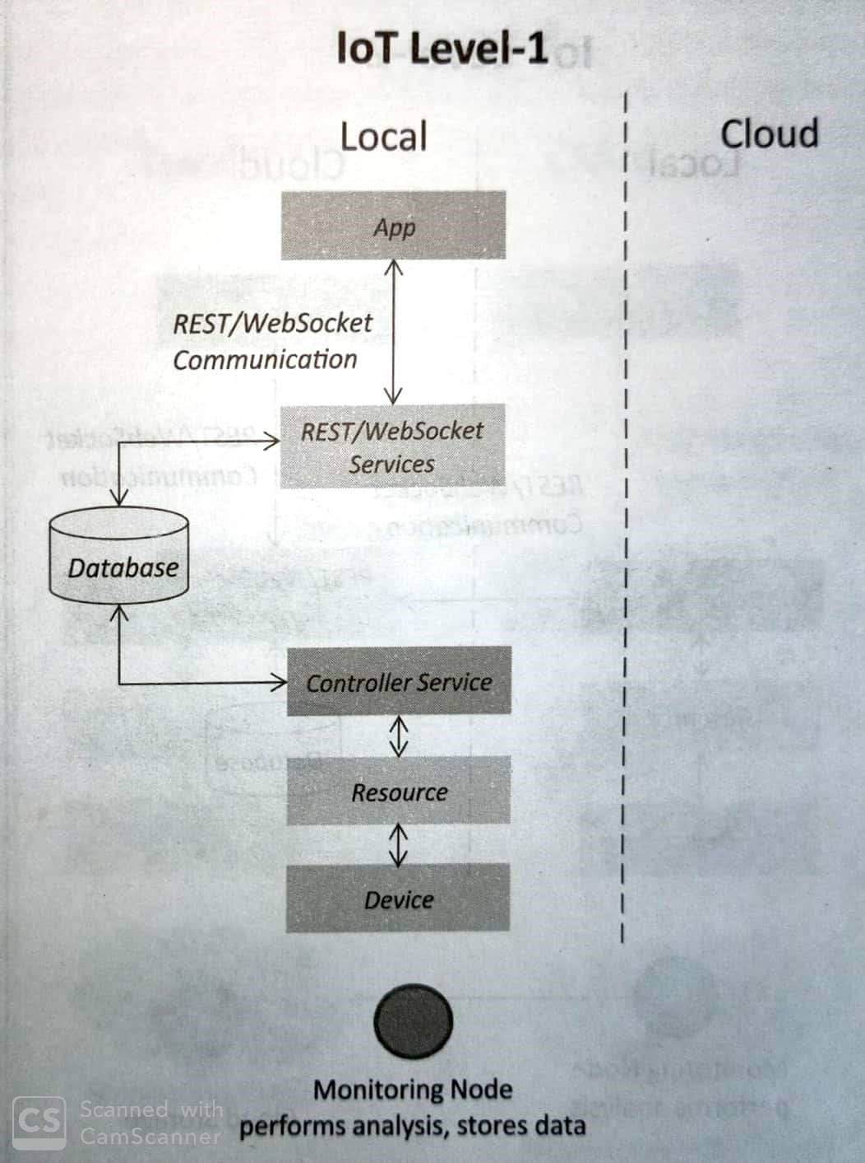

Figure 1.10: Block Diagram of IoT Level 1.

### 1.7.2 IoT Level-2

It has a single node that performs sensing and/or actuating and local analysis as shown in fig. Data is stored in cloud and application is usually cloud based. Level2 IoT systems are suitable for solutions where data are involved is big, however, the primary analysis requirement is not computationally intensive and can be done locally itself. An e,g., of Level2 IoT system for Smart Irrigation.

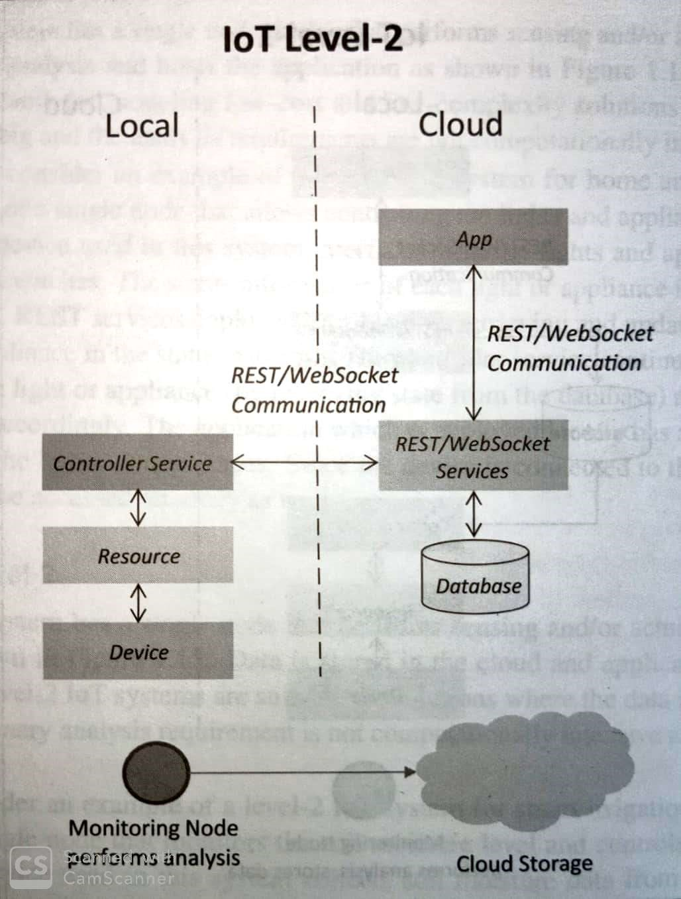

Figure 1.11: Block Diagram of IoT Level 2.

### 1.7.3 IoT Level-3

system has a single node. Data is stored and analyzed in the cloud application is cloud based as shown in fig. Level3 IoT systems are suitable for solutions where the data involved is big and analysis requirements are computationally intensive. An example of IoT level3 system for tracking package handling.

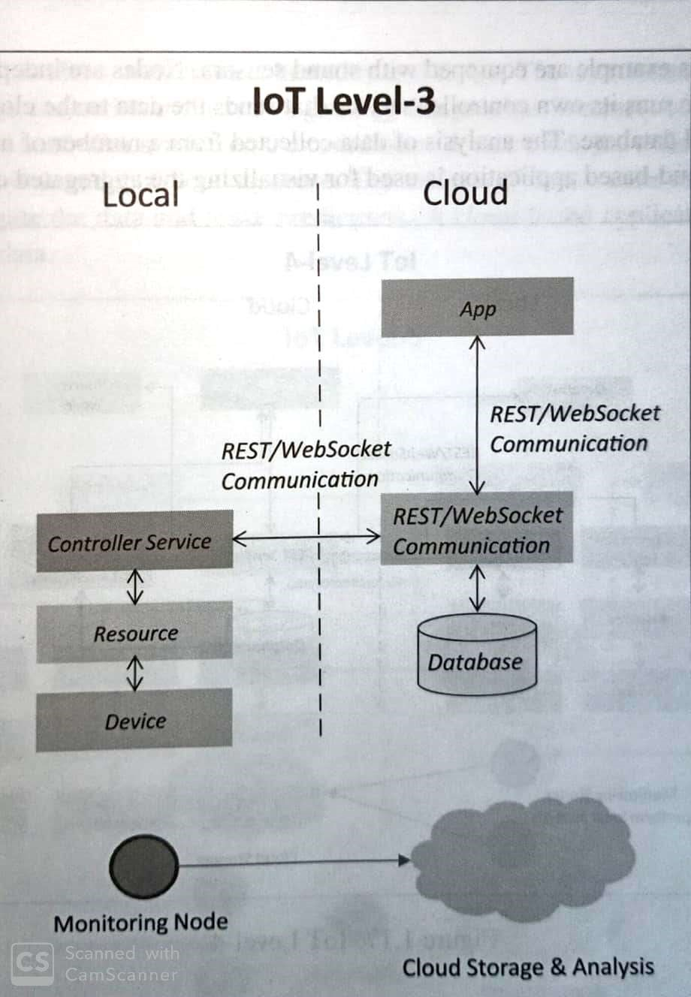

Figure 1.12: Block Diagram of IoT Level 3.

### 1.7.4 IoT Level-4

System has multiple nodes that perform local analysis. Data is stored in the cloud and application is cloud based as shown in fig. Level4 contains local and cloud based observer nodes which can subscribe to and receive information collected in the cloud from IoT devices. An example of a Level4 IoT system for Noise Monitoring.

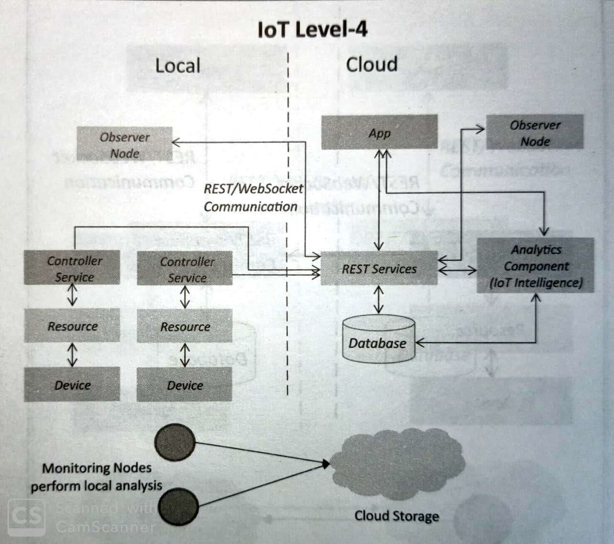

Figure 1.13: Block Diagram of IoT Level 4.

### 1.7.5 IoT Level-5

System has multiple end nodes and one coordinator node as shown in fig. The end nodes that perform sensing and/or actuation. Coordinator node collects data from the end nodes and sends to the cloud. Data are stored and analyzed in the cloud and application is cloud based. Level5 IoT systems are suitable for solution based on wireless sensor network, in which data involved is big and analysis requirements are computationally intensive. An example of Level5 system for Forest Fire Detection.

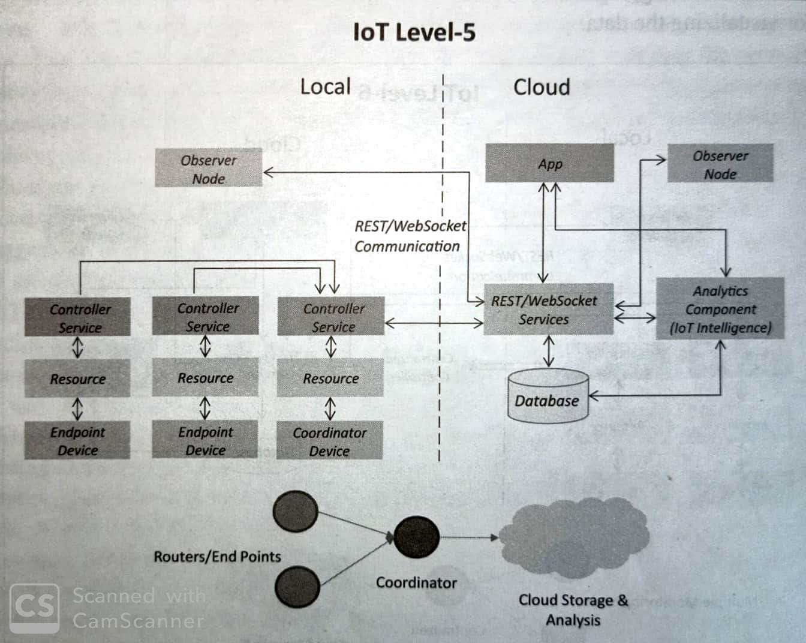

Figure 1.14: Block Diagram of IoT Level 5.

### 1.7.6 IoT Level-6

System has multiple independent end nodes that perform sensing and/or actuation and sensed data to the cloud. Data is stored in the cloud and application is cloud based as shown in fig. The analytics component analyses the data and stores the result in the cloud data base. The results are visualized with cloud based application. The centralized controller is aware of the status of all the end nodes and sends control commands to nodes. An example of a Level6 IoT system for Weather Monitoring System.

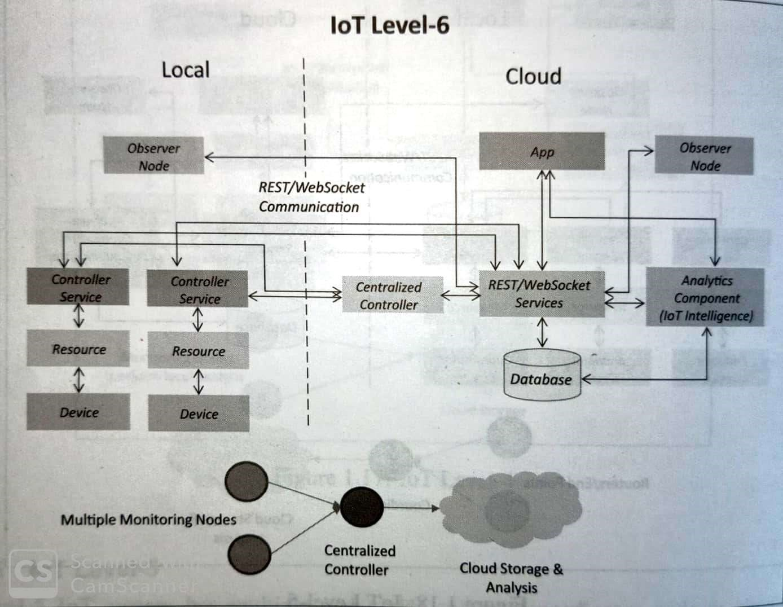

Figure 1.15: Block Diagram of IoT Level 6.

1.8 Layered Architecture:

The three-layer architecture defines the main idea of the Internet of Things, but it is not sufficient for research on IoT because research often focuses on finer aspects of the Internet of Things. That is why, we have many more layered architectures proposed in the literature. One is the five-layer architecture, which additionally includes the processing and business layers [3–6]. The five layers are perception, transport, processing, application, and business layers (see Figure 1.16). The role of the perception and application layers is the same as the architecture with three layers. We outline the function of the remaining three layers.

* The transport layer transfers the sensor data from the perception layer to the processing layer and vice versa through networks such as wireless, 3G, LAN, Bluetooth, RFID, and NFC.

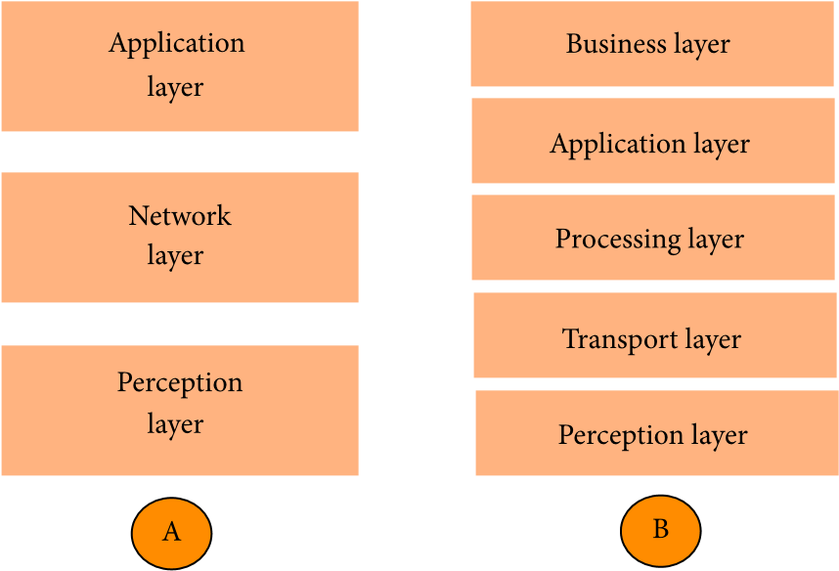

Figure 1.16: Architecture of IoT (A: three layers) (B: five layers).

* The processing layer is also known as the middleware layer. It stores, analyzes, and processes huge amounts of data that comes from the transport layer. It can manage and provide a diverse set of services to the lower layers. It employs many technologies such as databases, cloud computing, and big data processing modules.
* The business layer manages the whole IoT system, including applications, business and profit models, and users’ privacy. The business layer is out of the scope of this paper. Hence, we do not discuss it further.

## 1.9 IoT and M2M

1.9.1 M2M:

Machine-to-Machine (M2M) refers to networking of machines(or devices) for the purpose of remote monitoring and control and data exchange.

* Term which is often synonymous with IoT is Machine-to-Machine (M2M).
* IoT and M2M are often used interchangeably.

Fig- 1.16Shows the end-to-end architecture of M2M systems comprises of M2M area networks, communication networks and application domain.

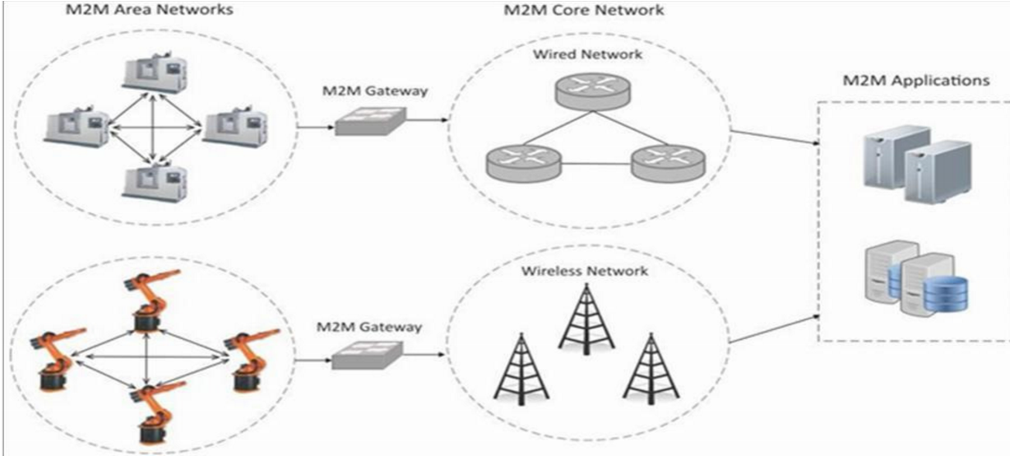

Figure 1.17: M2M Architecture.

* An M2M area network comprises of machines( or M2M nodes) whiach have embedded network modules for sensing, actuation and communicating various communication protocols can be used for M2M LAN such as ZigBee, Bluetooth, M-bus, Wireless M-Bus etc., These protocols provide connectivity between M2M nodes within an M2M area network. • The communication network provides connectivity to remote M2M area networks. The communication network provides connectivity to remote M2M area network. The communication network can use either wired or wireless network(IP based). While the M2M are networks use either properietorary or non-IP baed communication protocols, the communication network uses IP-based network. Since non-IP based protocols are used within M2M area network, the M2M nodes within one network cannot communicate with nodes in an external network.
* To enable the communication between remote M2M are network, M2M gateways are used.

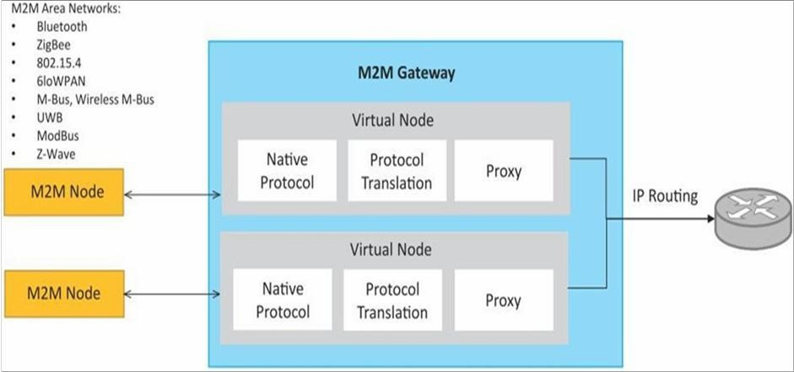

Figure 1.18: M2M Network.

Fig-1.17 Shows a block diagram of an M2M gateway. The communication between M2M nodes and the M2M gateway is based on the communication protocols which are naive to the M2M are network. M2M gateway performs protocol translations to enable Ip-connectivity for M2M are networks. M2M gateway acts as a proxy performing translations from/to native protocols to/from Internet Protocol(IP). With an M2M gateway, each mode in an M2M area network appears as a virtualized node for external M2M area networks.

## 1.10 Differences between IoT and M2M

1. Communication Protocols • Commonly uses M2M protocols include ZigBee, Bluetooth, ModBus, M-Bus, Wireless M-Bustec.
   * In IoT uses HTTP, CoAP, WebSocket, MQTT, XMPP, DDS, AMQPetc.
2. Machines in M2M Vs Things in IoT • Machines in M2M will be homogeneous whereas Things in IoT will be heterogeneous.
3. Hardware Vs Software Emphasis • the emphasis of M2M is more on hardware with embedded modules, the emphasis of IoT is more on software.
4. Data Collection and Analysis • M2M data is collected in point solutions and often in on-premises storage infrastructure.
   * The data in IoT is collected in the cloud (can be public, private or hybrid cloud).
5. Applications • M2M data is collected in point solutions and can be accessed by onpremises applications such as diagnosis applications, service management applications, and on-premises enterprise applications. • IoT data is collected in the cloud and can be accessed by cloud applications such as analytics applications, enterprise applications, remote diagnosis and management applications,etc.

Chapter 2

# Domain Specific IoTs

2.1 Home Automation:

* Smart Lighting: helps in saving energy by adapting the lighting to the ambient conditions and switching on/off or dimming the light when needed. • Smart Appliances: make the management easier and also provide status information to the users remotely.
* Intrusion Detection: use security cameras and sensors(PIR sensors and door sensors) to detect intrusion and raise alerts. Alerts can be in the form of SMS or email sent to the user.
* Smoke/Gas Detectors: Smoke detectors are installed in homes and buildings to detect smoke that is typically an early sign of fire. Alerts raised by smoke detectors can be in the form of signals to a fire alarm system. Gas detectors can detect the presence of harmful gases such as CO, LPG etc.,

2.2 Cities:

* Smart Parking: make the search for parking space easier and convenient for drivers. Smart parking are powered by IoT systems that detect the no. of empty parking slots and send information over internet to smart application back-ends.
* Smart Lighting: for roads, parks and buildings can help in savingenergy. • Smart Roads: Equipped with sensors can provide information on driving condition, travel time estimating and alert in case of poor driving conditions, traffic condition and accidents.
* Structural Health Monitoring: uses a network of sensors to monitor the vibration levels in the structures such as bridges and buildings.
* Surveillance: The video feeds from surveillance cameras can be aggregated in cloud based scaleable storage solution.
* Emergency Response: IoT systems for fire detection, gas and water leakage detection can help in generating alerts and minimizing their effects on the critical infrastructures.

2.3 Environment:

* Weather Monitoring: Systems collect data from a no. of sensors attached and send the data to cloud based applications and storage back ends. The data collected in cloud can then be analyzed and visualized by cloud based applications.
* Air Pollution Monitoring: System can monitor emission of harmful gases(CO2, CO, NO, NO2 etc.,) by factories and automobiles using gaseous and meteorological sensors. The collected data can be analyzed to make informed decisions on pollution control approaches.
* Noise Pollution Monitoring: Due to growing urban development, noise levels in cities have increased and even become alarmingly high in some cities. IoT based noise pollution monitoring systems use a no. of noise monitoring systems that are deployed at different places in a city. The data on noise levels from the station is collected on servers or in the cloud. The collected data is then aggregated to generate noise maps.
* Forest Fire Detection: Forest fire can cause damage to natural resources, property and human life. Early detection of forest fire can help in minimizing damage.
* River Flood Detection: River floods can cause damage to natural and human resources and human life. Early warnings of floods can be given by monitoring the water level and flow rate. IoT based river flood monitoring system uses a no. of sensor nodes that monitor the water level and flow rate sensors.

Introduction to Internet of Things

2.4 Energy:

* Smart Grids: is a data communication network integrated with the electrical grids that collects and analyze data captured in near-real-time about power transmission, distribution and consumption. Smart grid technology provides predictive information and recommendations to utilities, their suppliers, and their customers on how best to manage power. By using IoT based sensing and measurement technologies, the health of equipment and integrity of the grid can be evaluated.
* Renewable Energy Systems: IoT based systems integrated with the transformers at the point of interconnection measure the electrical variables and how much power is fed into the grid. For wind energy systems, closedloop controls can be used to regulate the voltage at point of interconnection which coordinate wind turbine outputs and provides power support. • Prognostics: In systems such as power grids, real-time information is collected using specialized electrical sensors called Phasor Measurement Units (PMUs) at the substations. The information received from PMUs must be monitored in real-time for estimating the state of the system and for predicting failures.

Bhabani Shankar Pradhan

Chapter 3

# Elements of IoT

## 3.1 Hardware Components

IoT supports various types of hardware among the following are the few examples of IoT hardware.

### 3.1.1 Basic Building Blocks of IoT Devices

An IoT device can consisting of number of modules based functional attributes such as:

* Sensing:
* Actuation:
* Communication:
* Analysis and Processing:

### 3.1.2 Raspberry Pi

The Raspberry Pi is a series of small single-board computers developed in the United Kingdom by the Raspberry Pi Foundation to promote teaching of basic computer science in schools and in developing countries.The original model became far more popular than anticipated, selling outside its target market for uses such as robotics. It does not include peripherals (such as keyboards and mice) or cases. However, some accessories have been included in several official and unofficial bundles.

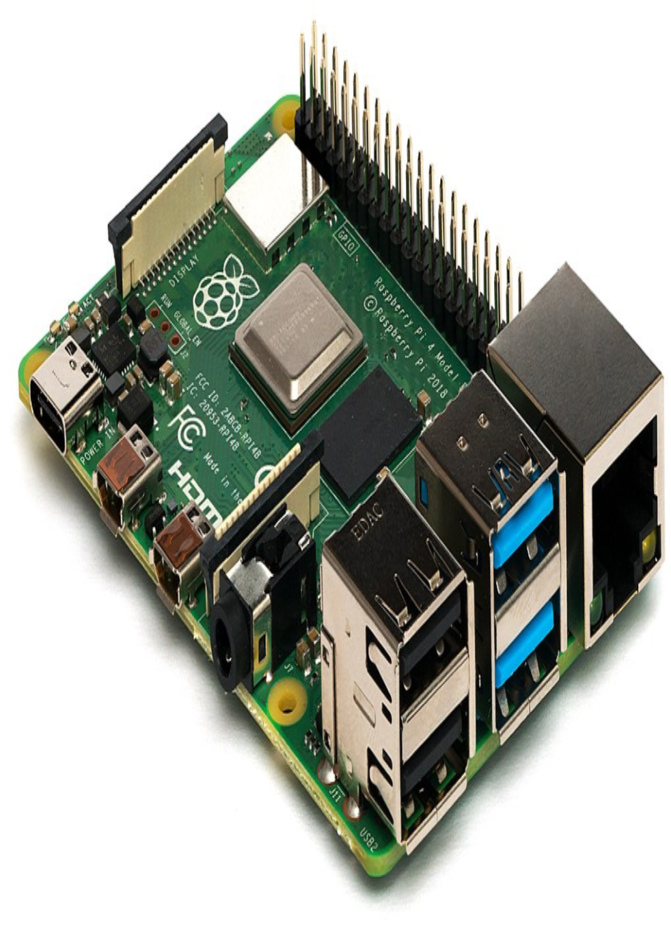

Figure 3.1: Raspberry Pi Model 3B.

28

I/O

CPU/GPU

RAM

USB hub

Ethernet

2

x USB

Figure 3.2: Raspberry Pi Model 3B Block Diagram.

Raspberry Pi 3 Model B was released in February 2016 with a 1.2 GHz 64-bit quad core processor, on-board 802.11n Wi-Fi, Bluetooth and USB boot capabilities.On Pi Day 2018 the Raspberry Pi 3 Model B+ was launched with a faster 1.4 GHz processor and a three-times faster gigabit Ethernet (throughput limited to ca. 300 Mbit/s by the internal USB 2.0 connection) or 2.4 / 5 GHz dual-band 802.11ac Wi-Fi (100 Mbit/s). Other features are Power over Ethernet (PoE) (with the add-on PoE HAT), USB boot and network boot (an SD card is no longer required).

The Raspberry Pi Model B features:

1. More GPIO
2. More USB
3. Micro SD
4. Lower power consumption
5. Better audio
6. Neater form factor

Figure 3.3: Raspberry Pi Model 3B Pin Diagram.

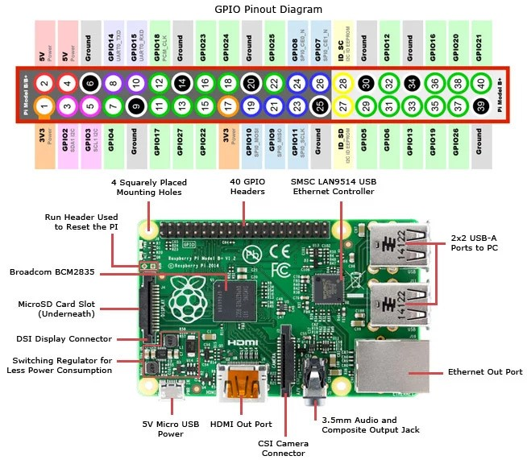

30

This higher-spec variant increases the Raspberry pi GPIO pin count from 26 to 40 pins. There are now four USB 2.0 ports compared to two on the Model B. The SD card slot has been replaced with a more modern push-push type micro SD slot. It consumes slightly less power, provides better audio quality and has a cleaner form factor.

To get started you need a Raspberry Pi 3 Model B, a 5V USB power supply of at least 2 amps with a micro USB cable, any standard USB keyboard and mouse, an HDMI cable and monitor/TV for display, and a micro SD card with the operating system pre-installed.

#### General Purpose Input Output(GPIO)

A powerful feature of the Raspberry Pi is the row of GPIO (general-purpose input/output) pins along the top edge of the board. A 40-pin GPIO header is found on all current Raspberry Pi boards (unpopulated on Pi Zero and Pi Zero W). Prior to the Pi 1 Model B+ (2014), boards comprised a shorter 26-pin header.

Any of the GPIO pins can be designated (in software) as an input or output pin and used for a wide range of purposes.

#### GPIO in Python

Using the GPIO Zero library makes it easy to get started with controlling GPIO devices with Python.

#### GPIO Logical Pin Numbers

Every GPIO pins are assigned with logical numbers as shown in the following figure:

### 3.1.3 Raspberry Pi Interfaces

Raspberry Pi has serial,SPI and I2C interface for data transfer.

1. Serial:
2. SPI:
3. I2C:

LED

To control an LED connected to GPIO17, you can use this code:

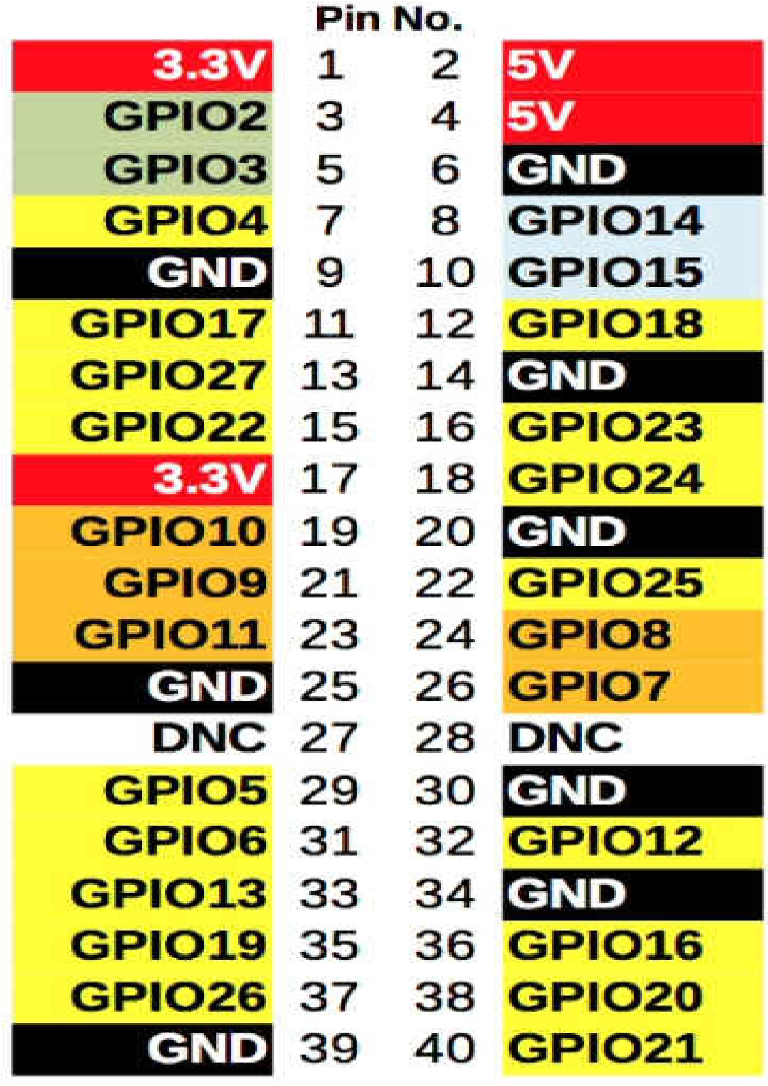

Figure 3.4: Raspberry Pi Model 3B GPIO Pin Logical Numbers.

Listing 3.1: LED.py

from gpiozero import LED from time import sleep led = LED(17) while True: led.on() sleep(1) led.off() sleep(1)

Run this in an IDE like Thonny, and the LED will blink on and off repeatedly.

LED methods include on(), off(), toggle(), and blink().

Button

To read the state of a button connected to GPIO2, you can use this code:

Listing 3.2: Button.py

|  |
| --- |
| from gpiozero import Button from time import sleep button = Button(2) while True: if button.is\_pressed: print("Pressed")  else: print("Released")  sleep(1) |

Button functionality includes the properties is pressed and is held; callbacks when pressed, when released, and when held; and methods wait for press() and wait for release.

Button + LED

To connect the LED and button together, you can use this code:

Listing 3.3: LED with Button.py

|  |
| --- |
| from gpiozero import LED, Button led = LED(17) button = Button(2) while True: if button.is\_pressed: led.on()  else: led.off() |

### 3.1.4 Arduino

Arduino is an open-source platform used for building electronics projects. Arduino consists of both a physical programmable circuit board (often referred to as a microcontroller) and a piece of software, or IDE (Integrated Development Environment) that runs on your computer, used to write and upload computer code to the physical board.

The Arduino platform has become quite popular with people just starting out with electronics, and for good reason. Unlike most previous programmable circuit boards, the Arduino does not need a separate piece of hardware (called a programmer) in order to load new code onto the board you can simply use a USB cable. Additionally, the Arduino IDE uses a simplified version of C++, making it easier to learn to program. Finally, Arduino provides a standard form factor that breaks out the functions of the micro-controller into a more accessible package.

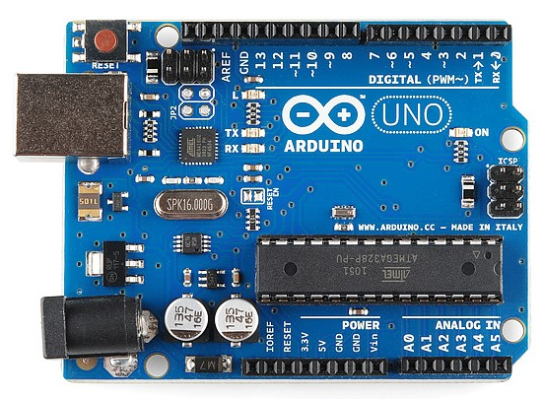

Figure 3.5: Arduino Uno board

The Uno is one of the more popular boards in the Arduino family and a great choice for beginners. We’ll talk about what’s on it and what it can do later in the tutorial.

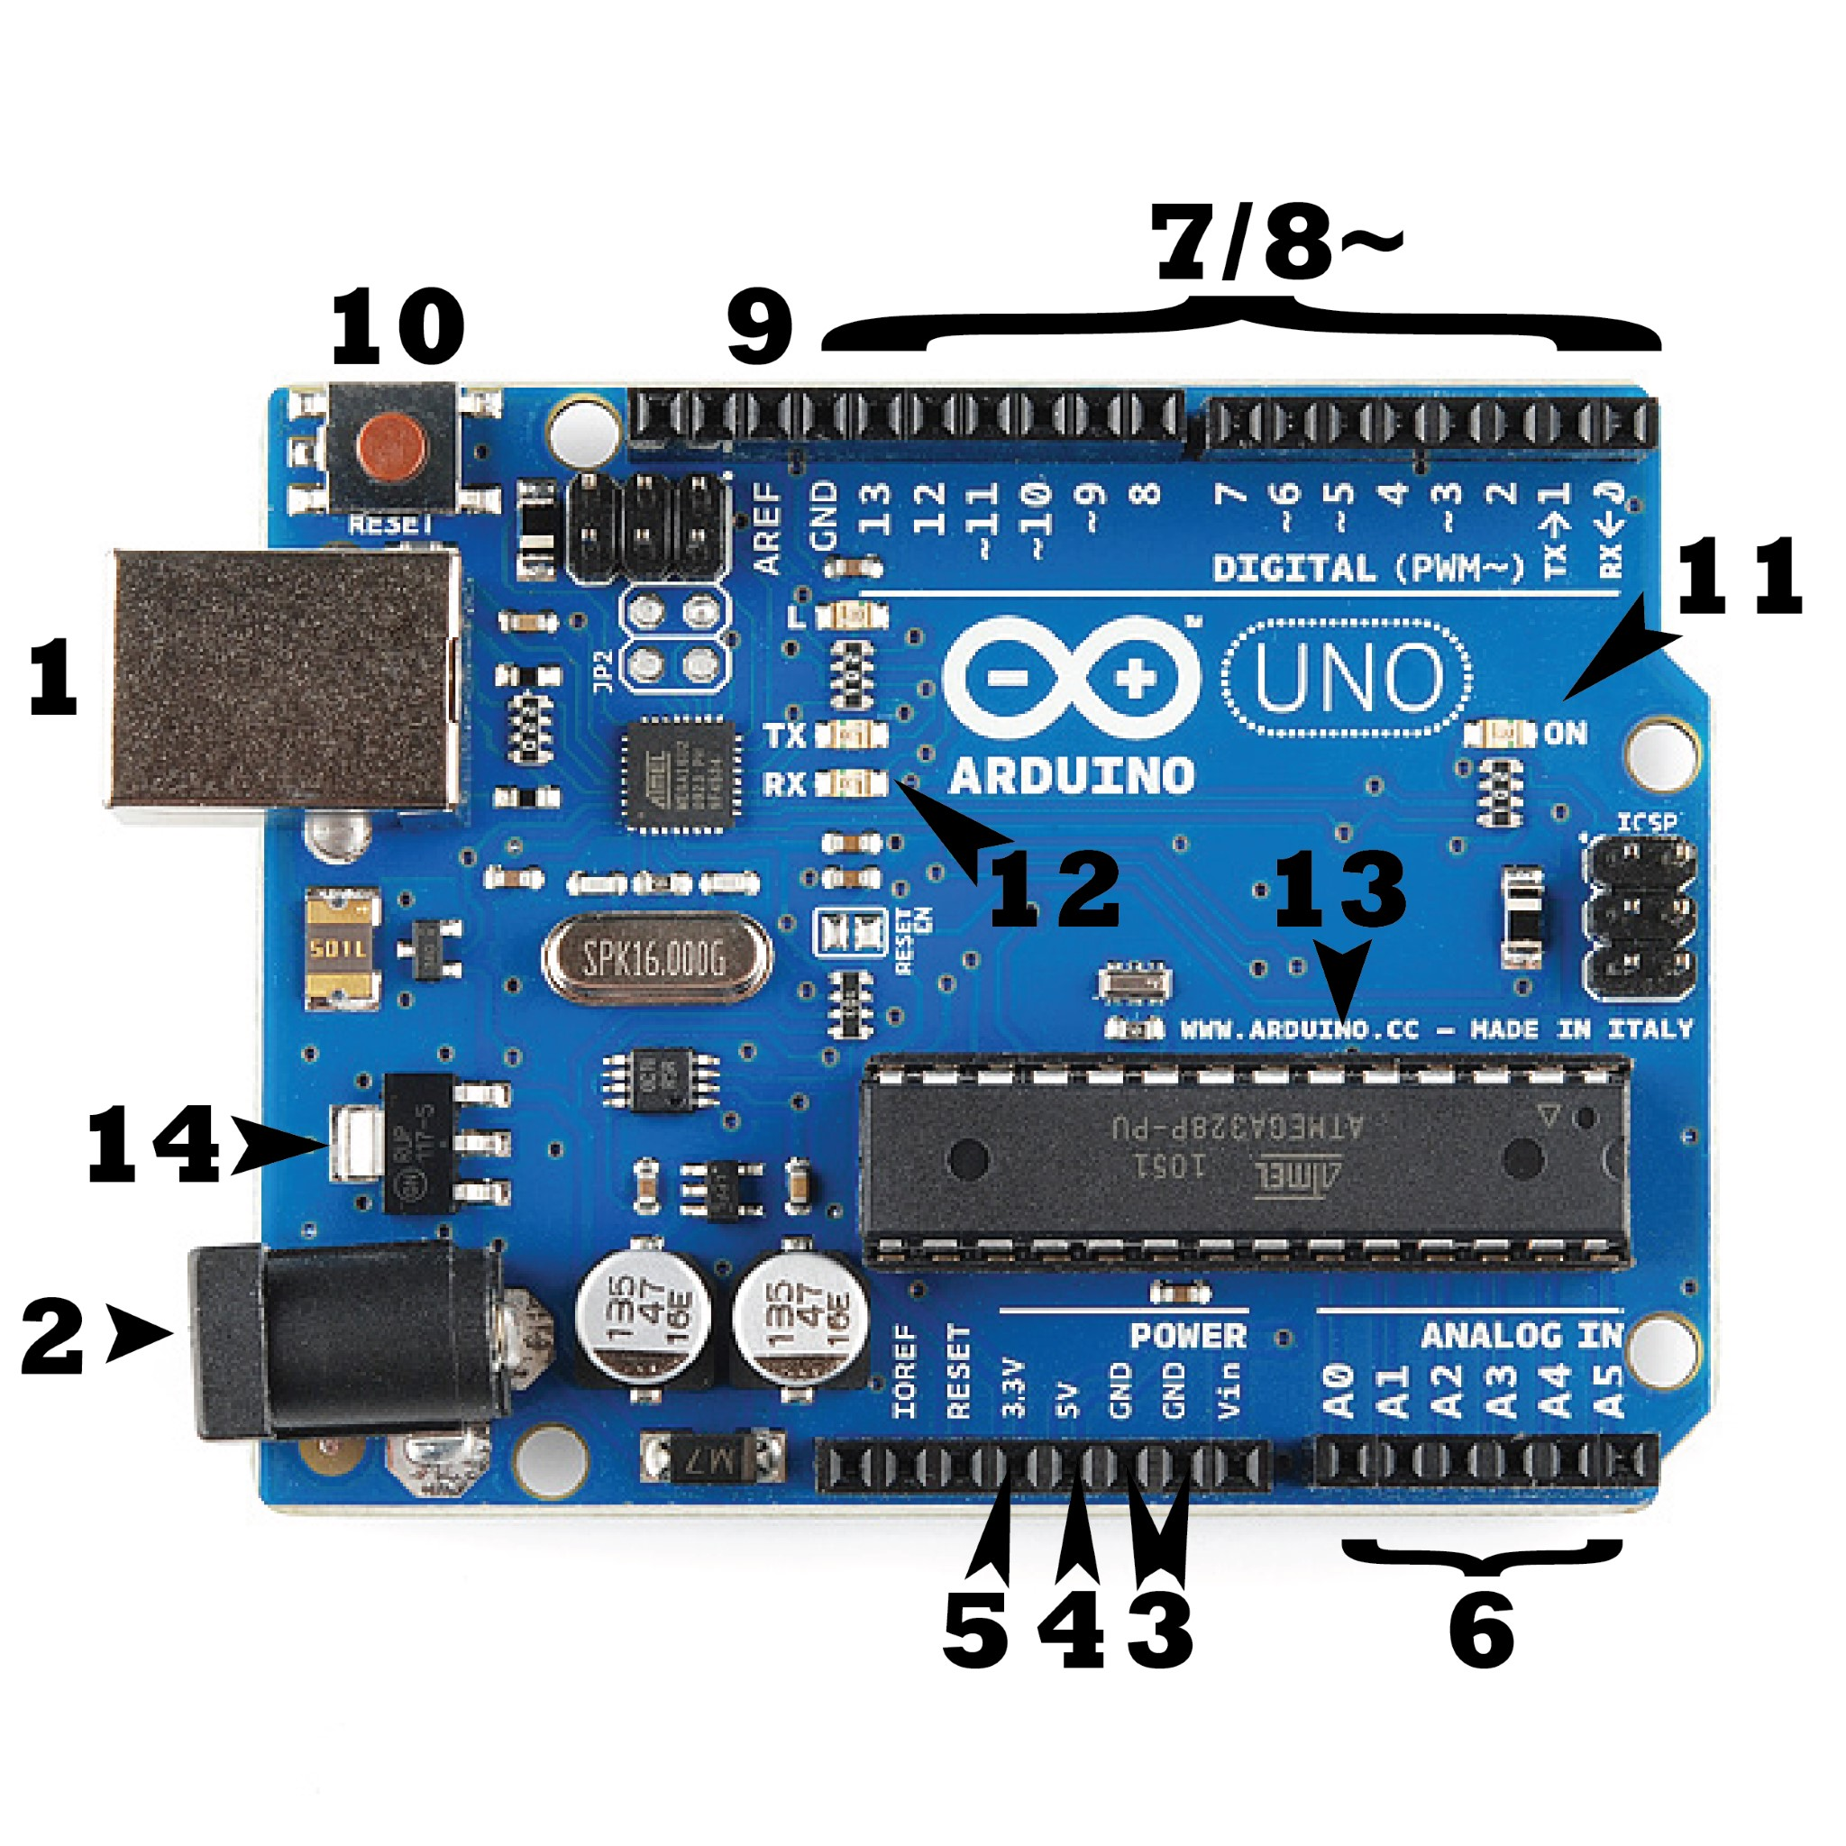

Figure 3.6: Arduino Uno board

#### Examples of Interfacing sensors with Arduino

Here are some examples of interfacing various sensors with arduino board.

Listing 3.4: DHT11.ino

|  |  |
| --- | --- |
| #include <DHT.h>;  *//Constants*  #define DHTPIN 7 *// what pin we’re connected to*  #define DHTTYPE DHT22 *// DHT 22 (AM2302)*  DHT dht(DHTPIN, DHTTYPE); *//// Initialize DHT sensor for normal 16mhz Arduino*  *//Variables* int chk; float hum; *//Stores humidity value* float temp; *//Stores temperature value* void setup() | |
| {  Serial.begin(9600); dht.begin();  }  void loop()  { delay(2000);  *//Read data and store it to variables hum and temp*  hum = dht.readHumidity(); temp= dht.readTemperature();  *//Print temp and humidity values to serial monitor*  Serial.print("Humidity:␣"); Serial.print(hum);  Serial.print("␣%,␣Temp:␣"); Serial.print(temp);  Serial.println("␣Celsius"); delay(10000); *//Delay 2 sec.*  } | |

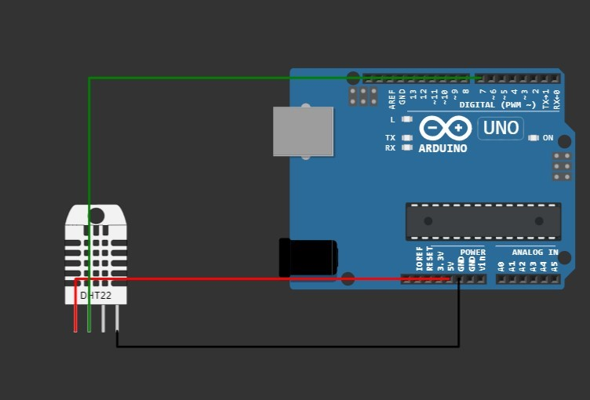

Figure 3.7: Arduino Uno board interfacing DHT sensor.

Listing 3.5: Ultrasonic.ino

#define echoPin 9 #define trigPin 11 long duration; int distance;

|  |
| --- |
| void setup(){  Serial.begin(9600); pinMode(trigPin,OUTPUT); pinMode(echoPin,INPUT);  } void loop(){ digitalWrite(trigPin,LOW); delayMicroseconds(2); digitalWrite(trigPin,HIGH); delayMicroseconds(10); digitalWrite(trigPin,LOW); duration=pulseIn(echoPin,HIGH); distance=(duration*0.034/2); Serial.print("Distance␣:␣" );  Serial.print(distance);  Serial.println("␣cm␣"); delay(1000);  } |

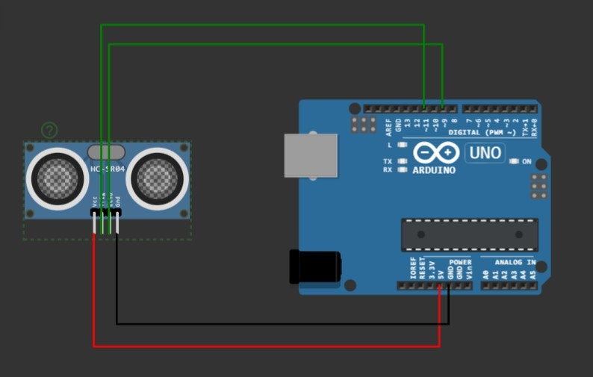

Figure 3.8: Arduino Uno board interfacing Ultrasonic sensor.

Listing 3.6: 16 X 2 LCD.ino

#include <LiquidCrystal.h> LiquidCrystal lcd(7, 6, 8, 9, 10, 11); void setup()

{

|  |
| --- |
| *// set up the LCD’s number of columns and rows:*  lcd.begin(16, 2); *// Print a message to the LCD*  *.*  lcd.print("This␣A␣Demo␣Class"); }  void loop()  { *// set the cursor to column 0, line 1 // (note: line 1 is the second row, since counting begins with 0): lcd.setCursor(0, 0);* lcd.print("␣Arduino␣LCD"); lcd.setCursor(0,1); lcd.print("Example␣");  } |

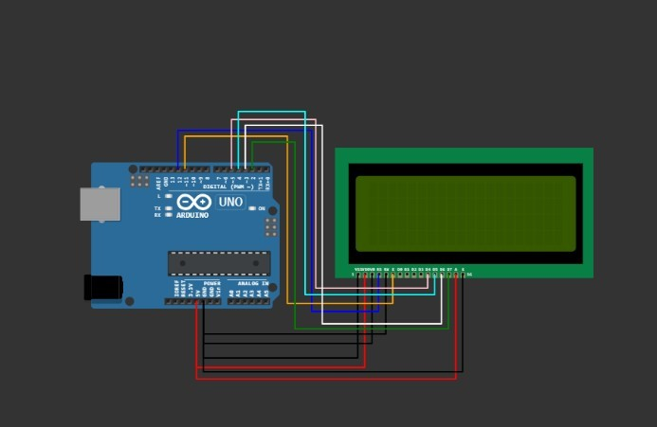

Figure 3.9: Arduino Uno board interfacing 16 X 2 LCD Display.

Chapter 4

# IoT Application Development

## 4.1 Introduction

An IoT application is an interface for the IoT environment which consists of application for data acquisition, data storage and data integration. It provides an API for enable the services of IoT environment.

An IoT application must have the following characteristics:

* Can provide information based on the data collected from the sensors.
* Data collection or Acquisition
* Data Storage - Cloud or local storage.
* Data integration - data are integrated to application.

## 4.2 Framework

Framework is a template. Which contains the basic working process of any application. The IoT framework should have basic working processes for enabling application of IoT environment.

## 4.3 Solution for IoT Application

The solution for IoT application must have a framework for the basic need of the application and the services to an IoT environment. IoT application must have:• Capability of connect to Internet.

* Share the data through Internet.
* A type of Web application.

## 4.4 Web Application in Python

Python is having two tools for web application development. Such as:

1. Flask
2. Django

### 4.4.1 Flask

Flask is a web framework that provides libraries to build lightweight web applications in python. It is developed by Armin Ronacher who leads an international group of python enthusiasts (POCCO).

Flask is based on Werkzeug WSGI(Web Server Gateway Interface) toolkit and Jinja2 template engine.

#### WSGI

It is an acronym for web server gateway interface which is a standard for python web application development. It is considered as the specification for the universal interface between the web server and web application.

#### Steps for Install Flask

1. Installation of virtual environment -pip install virtualenv
2. Create project folder:-mkdir newproj
3. Go to the folder newproj:- cd newproj
4. Greate virtual environment venv : virtualenv venv
5. Go to folder venv/bin/activate (Linux/Mac OS) or venv\scripts\activate (for Windows)
6. Install flask using the command ”pip install Flask”

#### First Flask application

In this section of the tutorial, we will build our first python website built using the Flask framework. In this process, open any text editor of your choice as we are using the sublime text editor or VS Code .

Write the following lines of code and save to a file named as script.py.

Listing 4.1: First Flask Example.

|  |
| --- |
| from flask import Flask app = Flask(__name__)  @app.route(’/’) def hello_world():  return ’Hello␣World’  if __name__ == ’__main__’:  app.run() |

To build the python web application, we need to import the Flask module. An object of the Flask class is considered as the WSGI application.

We need to pass the name of the current module, i.e. name as the argument into the Flask constructor.

The route() function of the Flask class defines the URL mapping of the associated function. The syntax is given below. app.route(rule, options)

#### Output

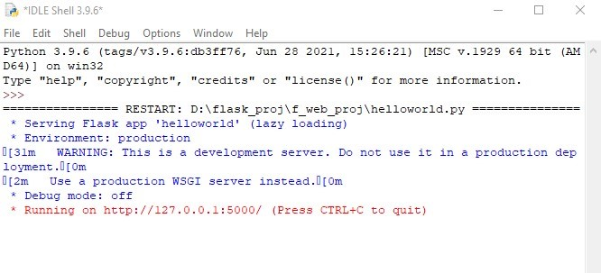

Figure 4.1: Output of the script.py

It accepts the following parameters.

1. rule: It represents the URL binding with the function.

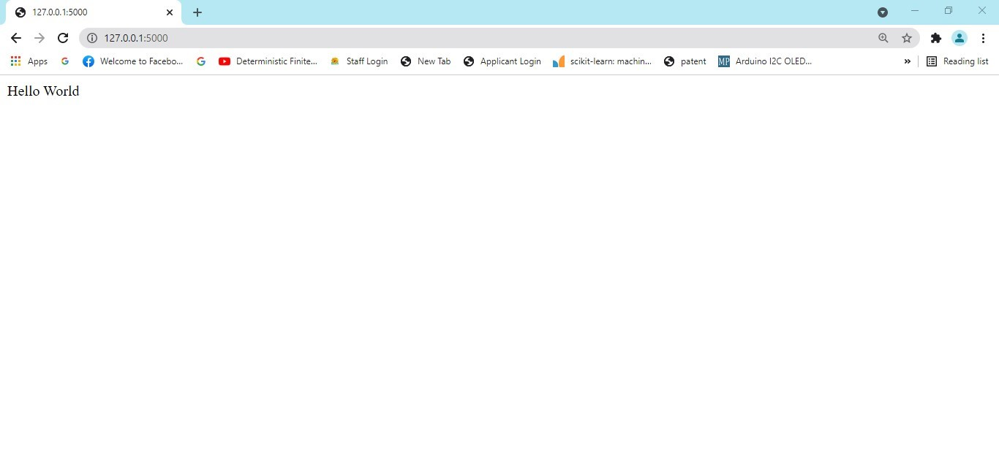

Figure 4.2: Output of the script.py on the browser.

1. options: It represents the list of parameters to be associated with the rule object

As we can see here, the / URL is bound to the main function which is responsible for returning the server response. It can return a string to be printed on the browser’s window or we can use the HTML template to return the HTML file as a response from the server.

Finally, the run method of the Flask class is used to run the flask application on the local development server.

#### The syntax is given below. app.run(host, port, debug, options)

|  |  |  |
| --- | --- | --- |
| SN | Option | Description |
| 1 | host | The default hostname is 127.0.0.1, i.e. localhost. |
| 2 | port | The port number to which the server is listening to. The default port number is 5000. |
| 3 | debug | The default is false. It provides debug information if it is set to true. |
| 4 | options | It contains the information to be forwarded to the server. |

Table 4.1: List of options for app.run()

#### Route Rules Example

App routing is used to map the specific URL with the associated function that is intended to perform some task. It is used to access some particular page like Flask Tutorial in the web application.

In our first application, the URL (’/’) is associated with the home function that returns a particular string displayed on the web page.

In other words, we can say that if we visit the particular URL mapped to some particular function, the output of that function is rendered on the browser’s screen. Listing 4.2: Variable Rule Example for different types variable.

|  |
| --- |
| from flask import Flask app = Flask(__name__)  @app.route(’/’) def index():  return ’Choose␣either␣hello␣or␣ranjit␣in␣the␣address .’  @app.route(’/hello’) def hello_world():  return ’Hello␣World’  @app.route(’/ranjit’) def test():  return ’Welcome␣Ranjit’  if __name__ == ’__main__’:  app.run() |

The following converters are used to convert the default string type to the associated data type.

1. string: default
2. int: used to convert the string to the integer 3. float: used to convert the string to the float.

4. path: It can accept the slashes given in the URL.

#### Variable Rules

It is possible to build a URL dynamically, by adding variable parts to the rule parameter. This variable part is marked as ¡variable-name¿. It is passed as a keyword argument to the function with which the rule is associated.

In the following example, the rule parameter of route() decorator contains

⟩name⟨ variable part attached to URL ‘/hello’. Hence, if the http://localhost:5000/hello/Aryan is entered as a URL in the browser, ‘Aryan’ will be supplied to hello() function as argument.

Listing 4.3: Variable Rule example.

|  |
| --- |
| from flask import Flask app = Flask(__name__)  @app.route(’/hello/<name>’) def hello_name(name): return ’Hello␣%s!’ % name  if __name__ == ’__main__’: app.run(debug = True) |

In the following example the integer and float variables are used in the variable rules.

Listing 4.4: Variable Rule for integer and float example.

|  |
| --- |
| from flask import Flask app = Flask(__name__)  @app.route(’/blog/<int:postID>’) def show_blog(postID): return ’Blog␣Number␣%d’ % postID  @app.route(’/rev/<float:revNo>’) def revision(revNo): return ’Revision␣Number␣%f’ % revNo  if __name__ == ’__main__’:  app.run() |

Run the above code from Python Shell. Visit the URL http://localhost:5000/blog/11 in the browser.

The given number is used as argument to the show blog() function. The browser displays the following output -

#### Blog Number 11

Enter this URL in the browser - http://localhost:5000/rev/1.1

The revision() function takes up the floating point number as argument. The following result appears in the browser window -

#### Revision Number 1.100000

The URL rules of Flask are based on Werkzeug’s routing module. This ensures that the URLs formed are unique and based on precedents laid down by Apache.

Listing 4.5: Werkzeug’s routing example.

|  |
| --- |
| from flask import Flask app = Flask(__name__)  @app.route(’/flask’) def hello_flask():  return ’Hello␣Flask’  @app.route(’/python/’) def hello_python():  return ’Hello␣Python’  if __name__ == ’__main__’:  app.run() |

Both the rules appear similar but in the second rule, trailing slash (/) is used. As a result, it becomes a canonical URL. Hence, using /python or /python/ returns the same output. However, in case of the first rule, /flask/ URL results in 404 Not Found page.

#### HTTP Response and Methods

HTTP is the hypertext transfer protocol which is considered as the foundation of the data transfer in the world wide web. All web frameworks including flask need to provide several HTTP methods for data communication. The methods are given in the following table.

|  |  |  |
| --- | --- | --- |
| SN | Method | Description |
| 1 | GET | It is the most common method which can be used to send data in the unencrypted form to the server. |
| 2 | HEAD | It is similar to the GET but used without the response body. |
| 3 | POST | It is used to send the form data to the server. The server does not cache the data transmitted using the post method. |
| 4 | PUT | It is used to replace all the current representation of the target resource with the uploaded content. |
| 5 | DELETE | It is used to delete all the current representation of the target resource specified in the URL. |

Table 4.2: List of HTTP responses in flask.

We can specify which HTTP method to be used to handle the requests in the route() function of the Flask class. By default, the requests are handled by the GET() method.

#### POST Method

To handle the POST requests at the server, let us first create a form to get some data at the client side from the user, and we will try to access this data on the server by using the POST request.

Listing 4.6: login.html for HTTP REsponce

|  |
| --- |
| <html>  <body>  <form action = "http://localhost:5000/login" method = "post">  <table>  <tr><td>Name</td>  <td><input type ="text" name ="uname"></td></tr  >  <tr><td>Password</td>  <td><input type ="password" name ="pass"></td>< /tr>  <tr><td><input type = "submit"></td></tr>  </table>  </form>  </body>  </html> |

Listing 4.7: login.py for HTTP Responce

|  |
| --- |
| from flask import Flask,render_template app = Flask(__name__)  @app.route(’/’) def index():  return render_template(’login.html’)  if __name__ == ’__main__’: app.run(debug = True) |

After the development server starts running, open login.html in the browser, enter name in the text field and click Submit.

Form data is POSTed to the URL in action clause of form tag.

http://localhost/login is mapped to the login() function. Since the server has received data by POST method, value of ‘nm’ parameter obtained from the form data is obtained by -

user = request.form[’nm’]

Change the method parameter to ‘GET’ in login.html and open it again in the browser. The data received on server is by the GET method. The value of ‘nm’ parameter is now obtained by User = request.args.get(‘nm’)

Here, args is dictionary object containing a list of pairs of form parameter and its corresponding value. The value corresponding to ‘nm’ parameter is passed on to ‘/success’ URL as before.

#### Templates

It is possible to return the output of a function bound to a certain URL in the form of HTML. For instance, in the following script, hello() function will render ‘Hello World’ with ¡h1¿ tag attached to it.

Listing 4.8: Template for HTTP Responce without HTML file.

from f l a s k import Flask app = Flask ( name )

@app . route ( ’ / ’ ) def index ( ) : return ’<html><body><h1>HelloWorld </h1></body ></html>’

i f name == ’ main ’ : app . run ( debug = True )

However, generating HTML content from Python code is cumbersome, especially when variable data and Python language elements like conditionals or loops need to be put. This would require frequent escaping from HTML.

This is where one can take advantage of Jinja2 template engine, on which Flask is based. Instead of returning hardcode HTML from the function, a HTML file can be rendered by the render template() function.

Listing 4.9: Template for HTTP Responce with HTML file.

|  |
| --- |
| from flask import Flask app = Flask(__name__)  @app.route(’/’) def index():  return render_template(’hello.html’)  if __name__ == ’__main__’: app.run(debug = True) |

Flask will try to find the HTML file in the templates folder, in the same folder in which this script is present.

Project Folder hello.py template hello.html

The term ‘web templating system’ refers to designing an HTML script in which the variable data can be inserted dynamically. A web template system comprises of a template engine, some kind of data source and a template processor.

Flask uses jinja2 template engine. A web template contains HTML syntax interspersed placeholders for variables and expressions (in these case Python expressions) which are replaced values when the template is rendered.

The following code is saved as hello.html in the templates folder.

Listing 4.10: First Templates Example(Html file).

|  |
| --- |
| <!doctype html> <html>  <body>  <h1>Hello {{ name }}!</h1>  </body>  </html> |

Next, run the following script from Python shell.

Listing 4.11: First Templates ExamplePython file).

|  |
| --- |
| from flask import Flask, render_template app = Flask(__name__)  @app.route(’/hello/<user>’) def hello_name(user): return render_template(’hello.html’, name = user)  if __name__ == ’__main__’: app.run(debug = True) |

#### Accessing Data from CSV to HTML file

To access the data from csv/excel file in web page. Here the following python file executed first.

|  |
| --- |
| from flask import Flask, render_template import pandas as pd app = Flask(__name__)  df = pd.read_csv("C:/Users/r/Desktop/5th_IoT_Mark␣Foil. csv")  dict = pd.Series(df.MARKS.values,index = df.RollNo).  to_dict()  @app.route(’/result’) def result():  return render_template(’result.html’, result = dict  )  if __name__ == ’__main__’: app.run(debug = True) |

The result is being shown in the following html page.

|  |
| --- |
| <!doctype html>  <html>  <title>IoT CT1 Marks</title> <body>  <table border = 1>  {% for key, value in result.items() %} <tr>  <th> {{ key }} </th>  <td> {{ value }} </td>  </tr>  {% endfor %}  </table>  </body>  </html> |

#### Request Object

The data from a client’s web page is sent to the server as a global request object. In order to process the request data, it should be imported from the Flask module. Important attributes of request object are listed below -

* Form - It is a dictionary object containing key and value pairs of form parameters and their values.
* args - parsed contents of query string which is part of URL after question mark (?).
* Cookies - dictionary object holding Cookie names and values.
* files - data pertaining to uploaded file.
* method - current request method.

#### Sending Form Data to Template

The Form data received by the triggered function can collect it in the form of a dictionary object and forward it to a template to render it on a corresponding web page.

In the following example, ‘/’ URL renders a web page (student.html) which has a form. The data filled in it is posted to the ‘/result’ URL which triggers the result() function.

The results() function collects form data present in request.form in a dictionary object and sends it for rendering to result.html.

The template dynamically renders an HTML table of form data.

Given below is the Python code of application -

|  |
| --- |
| from flask import Flask, render_template, request app = Flask(__name__)  @app.route(’/’) def student():  return render_template(’student.html’)  @app.route(’/result’,methods = [’POST’, ’GET’]) def result():  if request.method == ’POST’:  result = request.form return render_template("result.html",result = result)  if __name__ == ’__main__’: app.run(debug = True) |

Given below is the HTML script of student.html.

|  |
| --- |
| <html>  <body>  <form action = "http://localhost:5000/result" method = "POST">  <p>Name <input type = "text" name = "Name" /></p>  <p>Physics <input type = "text" name = "Physics" /></p>  <p>Chemistry <input type = "text" name = "chemistry" /></p> |
| <p>Maths <input type ="text" name = "Mathematics" /></p> <p><input type = "submit" value = "submit" /></p>  </form>  </body>  </html> |

Code of template (result.html) is given below -

|  |
| --- |
| <!doctype html> <html>  <body>  <table border = 1>  {% for key, value in result.items() %} <tr>  <th> {{ key }} </th>  <td> {{ value }} </td>  </tr>  {% endfor %}  </table>  </body>  </html> |

Run the Python script and enter the URL http://localhost:5000/ in the browser.When the Submit button is clicked, form data is rendered on result.html in the form of HTML table.

#### Cookies

A cookie is stored on a client’s computer in the form of a text file. Its purpose is to remember and track data pertaining to a client’s usage for better visitor experience and site statistics.

A Request object contains a cookie’s attribute. It is a dictionary object of all the cookie variables and their corresponding values, a client has transmitted. In addition to it, a cookie also stores its expiry time, path and domain name of the site.

In Flask, cookies are set on response object. Use make response() function to get response object from return value of a view function. After that, use the set cookie() function of response object to store a cookie.

Reading back a cookie is easy. The get() method of request.cookies attribute is used to read a cookie.

In the following Flask application, a simple form opens up as you visit ‘/’ URL.

from flask import *

|  |
| --- |
| app = Flask(__name__)  @app.route(’/cookie’) def cookie():  res = make_response("<h1>cookie␣is␣set</h1>") res.set_cookie(’ranjit’,’This␣is␣test␣cookie␣for␣ the␣site.’)  return res  if __name__ == ’__main__’: app.run(debug = True) |

#### Sessions

The concept of a session is very much similar to that of a cookie. However, the session data is stored on the server.

The session can be defined as the duration for which a user logs into the server and logs out. The data which is used to track this session is stored into the temporary directory on the server.

The session data is stored on the top of cookies and signed by the server cryptographically.

In the flask, a session object is used to track the session data which is a dictionary object that contains a key-value pair of the session variables and their associated values.

Syntax The following syntax is used to set the session variable to a specific value on the server.

#### Session[⟨variable-name⟩] = ⟨value⟩

To remove a session variable, use the pop() method on the session object and mention the variable to be removed. session.pop(⟨variable-name⟩, none)

Let’s see a simple example to understand how can we set and get the session variable.

|  |
| --- |
| from flask import * app = Flask(__name__) app.secret_key = "abc"  @app.route(’/’) def home():  res = make_response("<h4>session␣variable␣is␣set,␣< a␣href=’/get’>  Get␣Variable</a></h4>") |
| session[’response’]=’session#1’ return res;  @app.route(’/get’) def getVariable():  if ’response’ in session:  s = session[’response’]; return render_template(’getsession.html’,name = s)  if __name__ == ’__main__’: app.run(debug = True) |

<html>

<head>

<title>getting the session</title>

</head>

<body>

<p>The session is set with value: <strong>{{name}}</ strong></p>

</body>

</html>

#### File Uploading

Example File uploading is the process of transmitting the binary or normal files to the server. Flask facilitates us to upload the files easily. All we need to have an HTML form with the encryption set to multipart/form-data.

The server-side flask script fetches the file from the request object using request.files[] Object. On successfully uploading the file, it is saved to the desired location on the server.

The uploaded file is saved to the temporary directory of the server for a while before it is saved to some desired location. The name of the destination file can be obtained using the following syntax. name = request.files[’file’].filename

The following python script will used for upload file into the server.

|  |
| --- |
| from flask import * app = Flask(__name__)  @app.route(’/’) def upload():  return render_template("file_upload_form.html")  @app.route(’/success’, methods = [’POST’]) def success(): |
| if request.method == ’POST’:  f = request.files[’file’] f.save(f.filename) return render_template("success.html", name = f  .filename)  if __name__ == ’__main__’: app.run(debug = True) |

The following html code will provide an interface for choose the file.

|  |
| --- |
| <html>  <head>  <title>upload</title>  </head> <body>  <form action = "/success" method =  "post" enctype="multipart/form-data">  <input type="file" name="file" />  <input type = "submit" value="Upload"> </form>  </body>  </html> |

The following html code will show the upload of file.

<html>

<head>

<title>success</title>

</head>

<body>

<p>File uploaded successfully</p>

<p>File Name: {{name}}</p>

</body>

</html>

#### Flask-Database Connection

Python has an in-built support for SQlite. SQlite3 module is shipped with Python distribution. For a detailed tutorial on using SQLite database in Python, please refer to this link. In this section we shall see how a Flask application interacts with SQLite.

Create an SQLite database ‘employee.db’ and create a Employees’ table in it.

In the following script the database is created and the manipulation operations are performed.

from flask import * import sqlite3

|  |  |
| --- | --- |
| app = Flask(__name__)  @app.route("/") def index():  return render_template("index.html");  @app.route("/add") def add():  return render_template("add.html")  @app.route("/savedetails",methods = ["POST","GET"]) def saveDetails():  msg = "msg" if request.method == "POST":  try:  name = request.form["name"] email = request.form["email"] address = request.form["address"] with sqlite3.connect("employee.db") as con:  cur = con.cursor() cur.execute("INSERT␣into  ␣Employees␣(name,␣email,␣address)␣values (?,?,?)",(name,email,address)) con.commit()  msg = "Employee␣successfully␣Added"  except:  con.rollback() msg = "We␣can␣not␣add␣the␣employee␣to␣the␣ list"  finally:  return render_template("success.html",msg = msg)  @app.route("/view") def view():  con = sqlite3.connect("employee.db") con.row_factory = sqlite3.Row cur = con.cursor() cur.execute("select␣*␣from␣Employees") rows = cur.fetchall() return render_template("view.html",rows = rows)  @app.route("/delete") def delete():  return render_template("delete.html")  @app.route("/deleterecord",methods = ["POST"]) | |
| def deleterecord():  id = request.form["id"] with sqlite3.connect("employee.db") as con:  try:  cur = con.cursor() cur.execute("delete␣from␣Employees␣where␣id  ␣=␣?",id) msg = "record␣successfully␣deleted"  except:  msg = "can’t␣be␣deleted"  finally:  return render_template("delete_record.html"  ,msg = msg)  if __name__ == "__main__": app.run(debug = True) | |

The following html codes are provides the interfaces for add Employee,Retrieve Employee and Delete Employee from the database.

Listing 4.12: Home Page UI.

|  |
| --- |
| <!DOCTYPE html>  <html>  <head>  <title>home</title>  </head> <body>  <h2>Hi, welcome to the website</h2>  <a href="/add">Add Employee</a><br><br>  <a href ="/view">List Records</a><br><br>  <a href="/delete">Delete Record</a><br><br>  </body>  </html> |

Listing 4.13: Add employee UI.

|  |  |
| --- | --- |
| <!DOCTYPE html>  <html>  <head>  <title>Add Employee</title>  </head> <body>  <h2>Employee Information</h2> | |
| <form action = "/savedetails" method="post">  <table>  <tr><td>Name</td><td><input type="text"  name="name"></td></tr>  <tr><td>Email</td><td>  <input type="email" name="email">  </td></tr>  <tr><td>Address</td><td>  <input type="text" name="address"> </td></tr>  <tr><td><input  type="submit" value="Submit"> </td></tr>  </table>  </form>  </body>  </html> | |

Listing 4.14: Delete employee UI.

|  |
| --- |
| <!DOCTYPE html>  <html>  <head>  <title>Delete Employee</title>  </head>  <body>  <h3>Remove Employee from the list</h3>  <form action="/deleterecord" method="post"> Employee Id <input type="text" name="id">  <input type="submit" value="Submit">  </form>  </body>  </html> |

Listing 4.15: Viwe employee UI.

<!DOCTYPE html>

<html>

<head>

|  |
| --- |
| <title>List</title>  </head>  <body>  <h3>Employee Information</h3>  <table border=5>  <thead>  <td>ID</td>  <td>Name</td>  <td>Email</td>  <td>Address</td>  </thead>  {% for row in rows %}  <tr>  <td>{{row["id"]}}</td>  <td>{{row["name"]}}</td>  <td>{{row["email"]}}</td>  <td>{{row["address"]}}</td>  </tr>  {% endfor %}  </table>  <br><br>  <a href="/">Go back to home page</a>  </body>  </html> |

### 4.4.2 Django

Django is a web development framework that assists in building and maintaining quality web applications. Django helps eliminate repetitive tasks making the development process an easy and time saving experience. This section gives a complete understanding of Django.

Django is a high-level Python web framework that encourages rapid development and clean, pragmatic design. Django makes it easier to build better web apps quickly and with less code.

#### Django – Design Philosophies

Django comes with the following design philosophies -

* Loosely Coupled - Django aims to make each element of its stack independent of the others.
* Less Coding - Less code so in turn a quick development.
* Don’t Repeat Yourself (DRY) - Everything should be developed only in exactly one place instead of repeating it again and again.
* Fast Development - Django’s philosophy is to do all it can to facilitate hyper-fast development.
* Clean Design - Django strictly maintains a clean design throughout its own code and makes it easy to follow best web-development practices.

#### Advantages of Django

Here are few advantages of using Django which can be listed out here • Object-Relational Mapping (ORM) Support - Django provides a bridge between the data model and the database engine, and supports a large set of database systems including MySQL, Oracle, Postgres, etc. Django also supports NoSQL database through Django-nonrel fork. For now, the only NoSQL databases supported are MongoDB and google app engine. • Multilingual Support - Django supports multilingual websites through its built-in internationalization system. So you can develop your website, which would support multiple languages.

* Framework Support - Django has built-in support for Ajax, RSS, Caching and various other frameworks.
* Administration GUI - Django provides a nice ready-to-use user interface for administrative activities.
* Development Environment - Django comes with a lightweight web server to facilitate end-to-end application development and testing.

As you already know, Django is a Python web framework. And like most modern framework, Django supports the MVC pattern. First let’s see what is the Model-View-Controller (MVC) pattern, and then we will look at Django’s specificity for the Model-View-Template (MVT) pattern.

#### MVC Pattern

When talking about applications that provides UI (web or desktop), we usually talk about MVC architecture. And as the name suggests, MVC pattern is based on three components: Model, View, and Controller. Model View Controller or MVC as it is popularly called, is a software design pattern for developing web applications. A Model View Controller pattern is made up of the following three parts -

* Model - The lowest level of the pattern which is responsible for maintaining data.
* View - This is responsible for displaying all or a portion of the data to the user.
* Controller - Software Code that controls the interactions between the Model and View.

#### DJANGO MVC - MVT Pattern

The Model-View-Template (MVT) is slightly different from MVC. In fact the main difference between the two patterns is that Django itself takes care of the Controller part (Software Code that controls the interactions between the Model and View), leaving us with the template. The template is a HTML file mixed with Django Template Language (DTL).

The following diagram illustrates how each of the components of the MVT pattern interacts with each other to serve a user request -

The developer provides the Model, the view and the template then just maps it to a URL and Django does the magic to serve it to the user.

#### Installing Django

Installing Django is very easy, but the steps required for its installation depends on your operating system. Since Python is a platform-independent language, Django has one package that works everywhere regardless of your operating system.

We assume you have your Django archive and python installed on your computer.

First, PATH verification.

On some version of windows (windows 7) you might need to make sure the Path system variable has the path the following C:\Python34\;C:\Python34\ Lib\site-packages\django\bin\in it, of course depending on your Python version.

Then, extract and install Django.

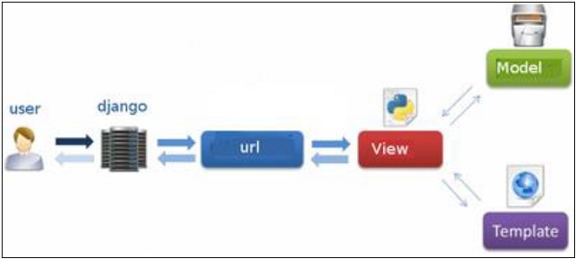

Figure 4.3: MVT Architecture of Django.

c:\>cdc:\Django-x.xx

Next, install Django by running the following command for which you will need administrative privileges in windows shell ”cmd” c:\Django-x.xx>python setup.py install

To test your installation, open a command prompt and type the following command c:\>python-c"importdjango;print(django.get_version())"

If you see the current version of Django printed on screen, then everything is set.

#### Create a Project in Django

Whether you are on Windows or Linux, just get a terminal or a cmd prompt and navigate to the place you want your project to be created, then use this codedjango-admin startproject myproject

This will create a ”myproject” folder with the following structure-

myproject/ manage.py myproject/ init .py settings.py urls.py wsgi.py

#### The Project Structure

The ”myproject” folder is just your project container, it actually contains two elements -

* manage.py - This file is kind of your project local django-admin for interacting with your project via command line (start the development server, sync db...). To get a full list of command accessible via manage.py you can use the code.
* The ”myproject” subfolder- This folder is the actual python package of your project. It contains four files -
  + init .py - Just for python, treat this folder as package.
  + settings.py - As the name indicates, your project settings.
  + urls.py - All links of your project and the function to call. A kind of ToC of your project.
  + wsgi.py - If you need to deploy your project over WSGI.

python manage.py help

#### Setting Up Your Project

Your project is set up in the subfolder myproject/settings.py. Following are some important options you might need to set-

#### DEBUG = True

This option lets you set if your project is in debug mode or not. Debug mode lets you get more information about your project’s error. Never set it to ‘True’ for a live project. However, this has to be set to ‘True’ if you want the Django light server to serve static files. Do it only in the development mode.

|  |
| --- |
| DATABASES = {  ’default’: {  ’ENGINE’: ’django.db.backends.sqlite3’,  ’NAME’: ’database.sql’,  ’USER’: ’’,  ’PASSWORD’: ’’,  ’HOST’: ’’,  ’PORT’: ’’,  }  } |

Database is set in the ‘Database’ dictionary. The example above is for SQLite engine. As stated earlier, Django also supports -

* MySQL (django.db.backends.mysql)
* PostGreSQL (django.db.backends.postgresql psycopg2)
* Oracle (django.db.backends.oracle) and NoSQL DB
* MongoDB (django mongodb engine)

Before setting any new engine, make sure you have the correct db driver installed.

You can also set others options like: TIME ZONE, LANGUAGE CODE, TEMPLATE...

Now that your project is created and configured make sure it’s working python manage.py runserver

You will get something like the following on running the above code-

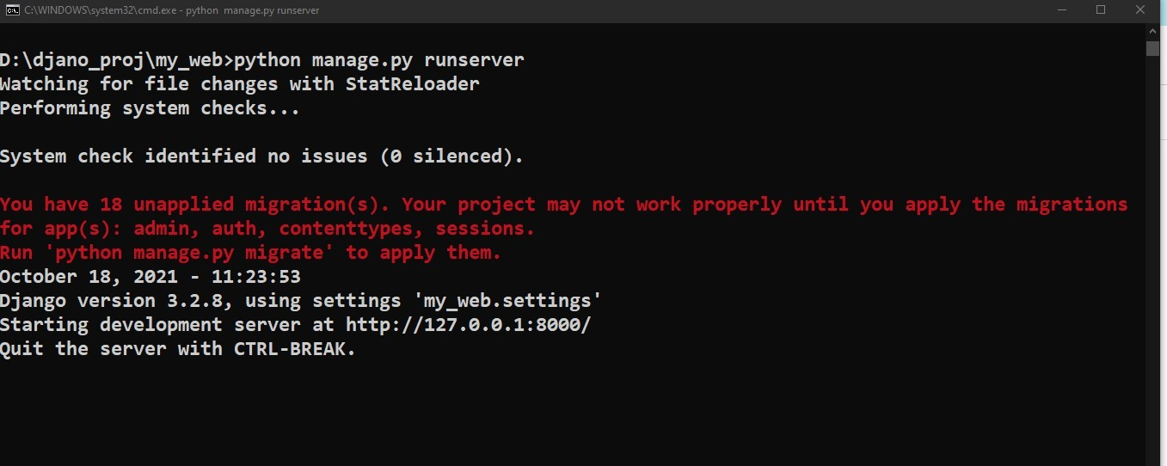

Figure 4.4: Django Server Running output.

#### Create an Application

A project is a sum of many applications. Every application has an objective and can be reused into another project, like the contact form on a website can be an application, and can be reused for others. See it as a module of your project.

We assume you are in your project folder. In our main “myproject” folder, the same folder then manage.py python manage.py startapp myapp

You just created myapp application and like project, Django create a “myapp” folder with the application structure myapp/

manage.py init .py admin.py models.py tests.py views.py

* init .py - Just to make sure python handles this folder as a package.
* admin.py - This file helps you make the app modifiable in the admin interface.
* models.py - This is where all the application models are stored.
* tests.py - This is where your unit tests are.
* views.py - This is where your application views are.

#### Get the Project to Know About Your Application

At this stage we have our ”myapp” application, now we need to register it with our Django project ”myproject”. To do so, update INSTALLED APPS tuple in the settings.py file of your project (add your app name) -

INSTALLED\_APPS = (

’django.contrib.admin’,

’django.contrib.auth’,

’django.contrib.contenttypes’,

’django.contrib.sessions’,

’django.contrib.messages’,

’django.contrib.staticfiles’,

’myapp’,

)

#### Starting the Admin Interface

Django provides a ready-to-use user interface for administrative activities. We all know how an admin interface is important for a web project. Django automatically generates admin UI based on your project models.

The Admin interface depends on the django.countrib module. To have it working you need to make sure some modules are imported in the INSTALLED APPS and MIDDLEWARE CLASSES tuples of the myproject/settings.py file.

#### URL Mapping

Well, till here, we have learned to create a model, view, and template. Now, we will learn about the routing of application.

Since Django is a web application framework, it gets user requests by URL locator and responds back. To handle URL, django.urls module is used by the framework.

Let’s open the file urls.py of the project and see the what it looks like:

from django.contrib import admin from django.urls import path

urlpatterns = [ path(’admin/’, admin.site.urls),

]

See, Django already has mentioned a URL here for the admin. The path function takes the first argument as a route of string or regex type.

The view argument is a view function which is used to return a response (template) to the user.

The django.urls module contains various functions, path(route,view,kwargs,name) is one of those which is used to map the URL and call the specified view.

from django.contrib import admin from django.urls import path from myapp import views

urlpatterns = [ path(’admin/’, admin.site.urls), path(’index/’, views.index), path(’hello/’, views.hello),

]

Now, start the server and enter localhost:8000/hello to the browser. This URL will be mapped into the list of URLs and then call the corresponding function from the views file.

In this example, hello will be mapped and call hello function from the views file. It is called URL mapping.

#### Django Static Files Handling

In a web application, apart from business logic and data handling, we also need to handle and manage static resources like CSS, JavaScript, images etc.

It is important to manage these resources so that it does not affect our application performance.

Django deals with it very efficiently and provides a convenient manner to use resources.

The django.contrib.staticfiles module helps to manage them.

Django Static (CSS, JavaScript, images) Configuration 1. Include the django.contrib.staticfiles in INSTALLED APPS.

|  |
| --- |
| INSTALLED_APPS = [  ’django.contrib.admin’,  ’django.contrib.auth’,  ’django.contrib.contenttypes’,  ’django.contrib.sessions’,  ’django.contrib.messages’,  ’django.contrib.staticfiles’,  ’myapp’  ] |

1. Define STATIC URL in settings.py file as given below.

STATIC_URL = ’/static/’

1. Load static files in the templates by using the below expression.

{% load static %}

1. Store all images, JavaScript, CSS files in a static folder of the application. First create a directory static, store the files inside it.

#### Django Image Loading Example

To load an image in a template file, use the code given below.

Listing 4.16: index.html

|  |
| --- |
| <!DOCTYPE html>  <html lang="en">  <head>  <meta charset="UTF-8">  <title>Index</title>  {% load static %}  </head>  <body>  <img src="{%␣static␣’/wallpaper.jpeg’␣%}" alt="My␣image  " height="300px" width="700px"/>  </body>  </html> |

Listing 4.17: urls.py

from django.contrib import admin from django.urls import path from myapp import views urlpatterns = [ path(’admin/’, admin.site.urls), path(’index/’, views.index), ]

Listing 4.18: views.py

def index(request): return render(request,’index.html’)

Run the server by using python manage.py runserver command.

After that access the template by localhost:8000/index URL, and it will produce the following output to the browser.

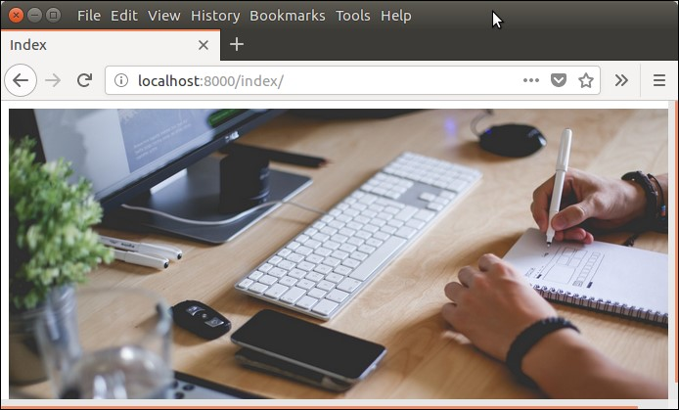

Figure 4.5: Django Image Loading Example.

#### Django Loading JavaScript

To load JavaScript file, just add the following line of code in index.html file.

{% load static %}

<script src="{%␣static␣’/js/script.js’␣%}"

Listing 4.19: index.html

|  |
| --- |
| <!DOCTYPE html>  <html lang="en">  <head>  <meta charset="UTF-8">  <title>Index</title>  {% load static %}  <script src="{%␣static␣’/js/script.js’␣%}" type  ="text/javascript"></script>  </head> <body>  </body>  </html> |

Listing 4.20: script.js

alert("Hello,␣Welcome␣to␣JavaScript␣File␣Access.");

Run the server by using python manage.py runserver command.

After that access the template by localhost:8000/index URL, and it will produce the following output to the browser.

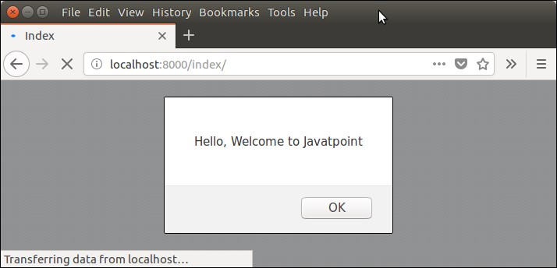

Figure 4.6: Django JScript Loading Example.

#### Django Loading CSS Example

To, load CSS file, use the following code in index.html file.

{% load static %}

<link href="{%␣static␣’css/style.css’␣%}" rel=" stylesheet">

After that create a directory CSS and file style.css which contains the following code.

Listing 4.21: style.css

h1{ color:red;

}

Listing 4.22: index.html

<!DOCTYPE html>

<html lang="en">

<head>

<meta charset="UTF-8">

<title>Index</title>

{% load static %}

<link href="{%␣static␣’css/style.css’␣%}" rel=" stylesheet">

</head>

<body>

<h1>Welcome to Django!!!</h1>

</body>

</html>

Run the server by using python manage.py runserver command.

After that access the template by entering localhost:8000/index URL, and it will produce the following output to the browser.

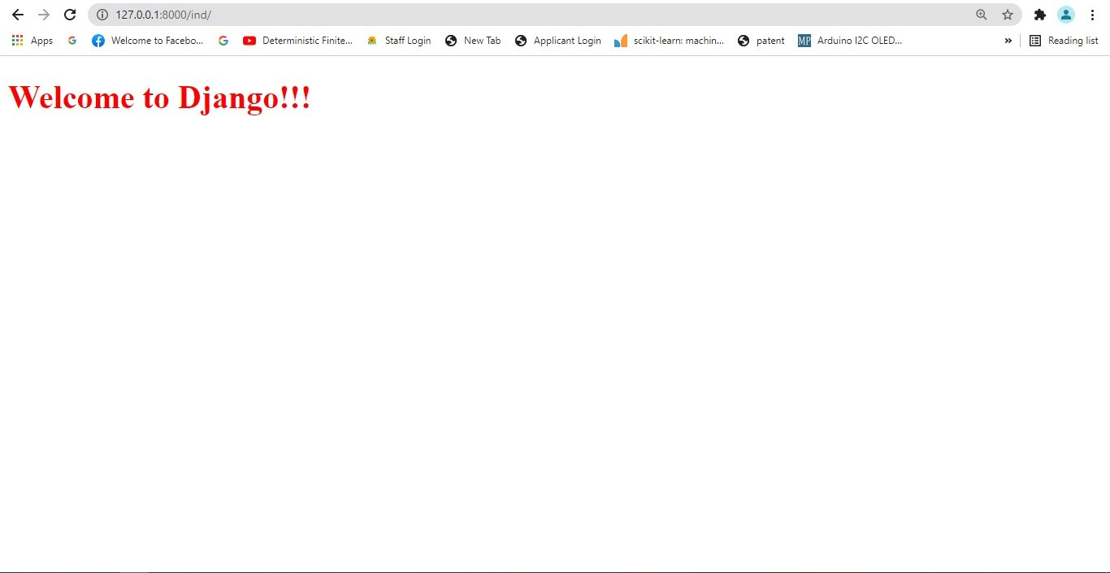

Figure 4.7: CSS file Loading Example.

#### Django Model Form

It is a class which is used to create an HTML form by using the Model. It is an efficient way to create a form without writing HTML code.

Django automatically does it for us to reduce the application development time. For example, suppose we have a model containing various fields, we don’t need to repeat the fields in the form file.

For this reason, Django provides a helper class which allows us to create a Form class from a Django model.

Let’s see an example.

First, create a model that contains fields name and other metadata. It can be used to create a table in database and dynamic HTML form.

Listing 4.23: model.py

from __future__ import unicode_literals from django.db import models class Student(models.Model):

|  |
| --- |
| first_name = models.CharField( max_length=20)  last_name = models.CharField( max_length=30)  class Meta: db_table = "student" |

This file contains a class that inherits ModelForm and mention the model name for which HTML form is created.

Listing 4.24: forms.py

|  |
| --- |
| from django import forms from myapp.models import Student  class EmpForm(forms.ModelForm): class Meta: model = Student fields = "__all__" |

Write a view function to load the ModelForm from forms.py.

Listing 4.25: views.py

|  |
| --- |
| from django.shortcuts import render from myapp.form import EmpForm def index(request): stu = EmpForm() return render(request,"index.html",{’form’:stu  }) |

Listing 4.26: urls.py

from django.contrib import admin from django.urls import path from myapp import views urlpatterns = [ path(’admin/’, admin.site.urls), path(’index/’, views.index),

]

And finally, create a index.html file that contains the following code.

Listing 4.27: index.html

<!DOCTYPE html>

<html lang="en">

<head>

<meta charset="UTF-8">

<title>Index</title>

</head>

<body>

<form method="POST" class="post-form">

{% csrf_token %}

{{ form.as_p }}

<button type="submit" class="save␣btn␣btn-default">Save

</button>

</form>

</body>

</html>

Run the server by using python manage.py runserver command.

After that access the template by localhost:8000/index URL, and it will produce the following output to the browser.

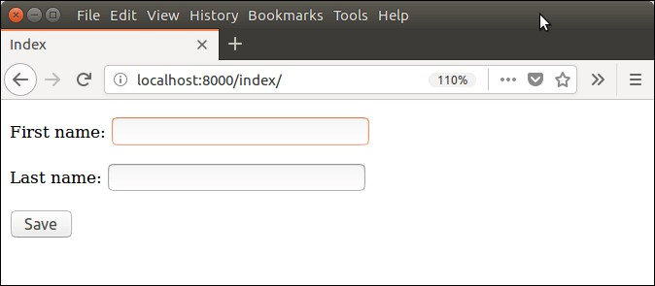

Figure 4.8: Django Model Form output.

Well, an HTML form is created automatically. This is a significant feature of Django.

#### Django Forms

Django provides a Form class which is used to create HTML forms. It describes a form and how it works and appears.

It is similar to the ModelForm class that creates a form by using the Model, but it does not require the Model.

Each field of the form class map to the HTML form ¡input¿ element and each one is a class itself, it manages form data and performs validation while submitting the form.

Lets see an example, in which we are creating some fields too.

|  |
| --- |
| from django import forms class StudentForm(forms.Form):  firstname = forms.CharField(label="Enter␣first␣name", max_length=50)  lastname = forms.CharField(label="Enter␣last␣name", max_length = 100) |

A StudentForm is created that contains two fields of CharField type. Charfield is a class and used to create an HTML text input component in the form.

The label is used to set HTML label of the component and max length sets length of an input value.

When rendered, it produces the following HTML to the browser.

|  |
| --- |
| <label for="id_firstname">Enter first name:</label>  <input type="text" name="firstname" required maxlength= "50" id="id_firstname" />  <label for="id_lastname">Enter last name:</label> < input type="text" name="lastname" required maxlength  ="100" id="id_lastname" /> |

Note: *Django Form does not include* ⟨*form*⟩ *tags, or a submit button. We’ll have to provide those ourselves in the template.*

Commonly used fields and their details are given in the below table 4.3.

Let’s see a complete example to create an HTML form with the help of Django Form class.

#### Building a Form in Django

Suppose we want to create a form to get Student information, use the following code.

Listing 4.28: forms.py

|  |
| --- |
| from django import forms class StudentForm(forms.Form): firstname = forms.CharField(label="Enter␣first␣ name",max_length=50)  lastname = forms.CharField(label="Enter␣last␣ name", max_length = 100) |

#### Instantiating Form in Django

Now, we need to instantiate the form in views.py file. See, the below code.

|  |  |  |  |
| --- | --- | --- | --- |
| Name | Class | HTML Input | Empty value |
| BooleanField | class Boolean-  Field(**kwargs) | CheckboxInput | False |
| CharField | class  CharField(**kwargs) | TextInput | Whatever you’ve given as empty value. |
| ChoiceField | class Choice-  Field(**kwargs) | Select | ” (an empty string) |
| DateField | class Date-  Field(**kwargs) | DateInput | None |
| DateTimeField | class DateTime-  Field(**kwargs) | DateTimeInput | None |
| DecimalField | class Decimal-  Field(**kwargs) | NumberInput | None |
| EmailField | class Email-  Field(**kwargs) | EmailInput | ” (an empty string) |
| FileField | class File-  Field(**kwargs) | ClearableFileInput | None |
| ImageField | class Image-  Field(**kwargs) | ClearableFileInput | None |

Table 4.3: Commonly used fields and their details

Listing 4.29: views.py

|  |
| --- |
| from django.shortcuts import render from myapp.form import StudentForm  def index(request):  student = StudentForm() return render(request,"index.html",{’form’:student}) |

Passing the context of form into index template that looks like this:

Listing 4.30: index.html

<!DOCTYPE html>

<html lang="en">

<head>

<meta charset="UTF-8">

<title>Index</title>

</head>

<body>

<form method="POST" class="post-form">

{% csrf_token %}

{{ form.as_p }}

<button type="submit" class="save␣btn␣btndefault">Save</button>

</form>

</body>

</html>

Provide the URL in urls.py

Listing 4.31: urls.py

from django.contrib import admin from django.urls import path from myapp import views urlpatterns = [ path(’admin/’, admin.site.urls), path(’index/’, views.index),

]

Run Server and access the form at browser by localhost:8000/index, and it will produce the following output.

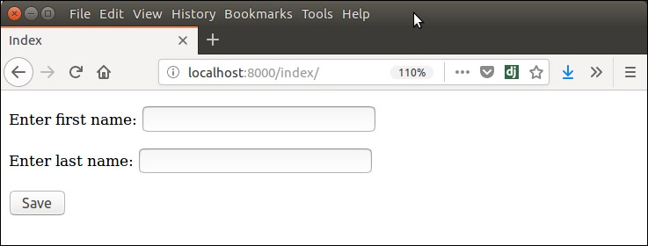

Figure 4.9: Django Model Form output.

There are other output options though for the ⟨label⟩/⟨input⟩ pairs:

* form.as table will render them as table cells wrapped in ⟨tr⟩ tags
* form.as p will render them wrapped in ⟨p⟩ tags
* form.as ul will render them wrapped in ⟨li⟩ tags

#### Django Form Validation

Django provides built-in methods to validate form data automatically. Django forms submit only if it contains CSRF tokens. It uses uses a clean and easy approach to validate data.

The is valid() method is used to perform validation for each field of the form, it is defined in Django Form class. It returns True if data is valid and place all data into a cleaned data attribute.

Let’s see an example that takes user input and validate input as well. This example contains the following files and code.

Listing 4.32: models.py

from django.db import models class Employee(models.Model):

eid = models.CharField(max_length=20) ename = models.CharField(max_length=100) econtact = models.CharField(max_length=15) class Meta:

db_table = "employee"

Now, create a form which contains the below code.

Listing 4.33: forms.py

|  |
| --- |
| from django import forms from myapp.models import Employee  class EmployeeForm(forms.ModelForm): class Meta: model = Employee fields = "__all__" |

Instantiate the form, check whether request is post or not. It validate the data by using is valid() method. Now, create a form which contains the below code.

Listing 4.34: forms.py

|  |  |
| --- | --- |
| def emp(request): if request.method == "POST": form = EmployeeForm(request.POST) if form.is_valid(): try:  return redirect(’/’)  except: pass  else: | |
| form = EmployeeForm() return render(request,’index.  html’,{’form’:form}) | |

Index template that shows form and errors.

Listing 4.35: index.html

<!DOCTYPE html>

<html lang="en">

<head>

<meta charset="UTF-8">

<title>Index</title>

</head>

<body>

<form method="POST" class="post-form" enctype=" multipart/form-data">

{% csrf_token %}

{{ form.as_p }}

<button type="submit" class="save␣btn␣btndefault">Save</button>

</form>

</body>

</html>

Start server and access the form.

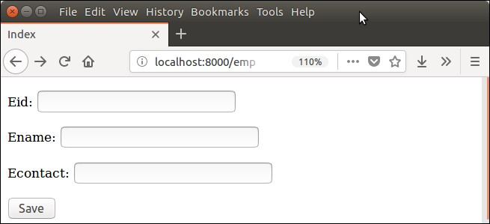

Figure 4.10: Django Model Form validation.

It validates each field and throws errors if any validation fails.

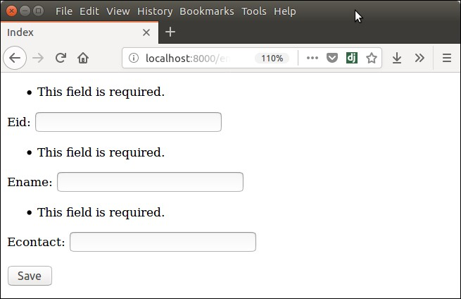

Figure 4.11: Django Model Form after validation.

#### Django File Upload

File upload to the server using Django is a very easy task. Django provides built-in library and methods that help to upload a file to the server.

The forms.FileField() method is used to create a file input and submit the file to the server. While working with files, make sure the HTML form tag contains enctype=”multipart/form-data” property.

Let’s see an example of uploading a file to the server. This example contains the following files.

Listing 4.36: index.html

<body>

<form method="POST" class="post-form" enctype=" multipart/form-data">

{% csrf_token %}

{{ form.as_p }}

<button type="submit" class="save␣btn␣btndefault">Save</button>

</form>

</body>

It will create an HTML form which contains a file input component.

Listing 4.37: forms.py

|  |
| --- |
| from django import forms class StudentForm(forms.Form):  firstname = forms.CharField(label="Enter␣first␣ name",max_length=50)  lastname = forms.CharField(label="Enter␣last␣ name", max_length = 10)  email = forms.EmailField(label="Enter␣Email  ")  file = forms.FileField() *# for creating file input* |

Here, one extra parameter request.FILES is required in the constructor. This argument contains the uploaded file instance.

Listing 4.38: views.py

|  |
| --- |
| from django.shortcuts import render from django.http import HttpResponse from myapp.functions.functions import handle_uploaded_file  from myapp.form import StudentForm def index(request): if request.method == ’POST’: student = StudentForm(request.POST, request.FILES)  if student.is_valid(): handle_uploaded_file(request.  FILES[’file’]) return HttpResponse("File␣ uploaded␣successfuly")  else:  student = StudentForm() return render(request,"index.html",{’ form’:student}) |

Listing 4.39: urls.py

from django.contrib import admin from django.urls import path from myapp import views urlpatterns = [ path(’admin/’, admin.site.urls), path(’index/’, views.index),

]

#### Upload Script (functions.py)

This function is used to read the uploaded file and store at provided location. Put this code into the functions.py file. But first create this file into the project.

Listing 4.40: functions.py

def handle_uploaded_file(f):

with open(’myapp/static/upload/’+f.name, ’wb+’) as destination: for chunk in f.chunks(): destination.write(chunk)

Now, create a directory upload to store the uploaded file under the templates folder. Initially, this directory is empty. so, let’s upload a file to it and later on it will contain the uploaded file.

Start Server python manage.py runserver

#### Output

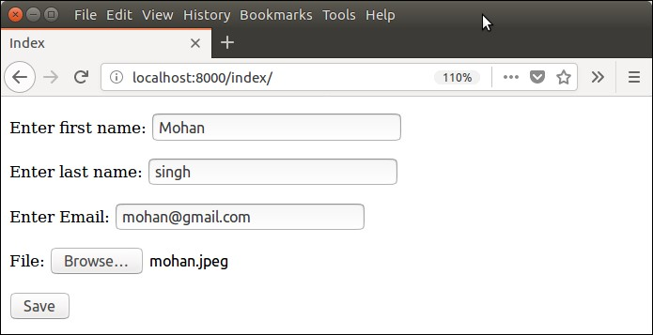

Figure 4.12: Django File uploading application.

#### Django Database Connectivity

The settings.py file contains all the project settings along with database connection details. By default, Django works with SQLite, database and allows configuring for other databases as well.

Database connectivity requires all the connection details such as database name, user credentials, hostname drive name etc.

To connect with MySQL, django.db.backends.mysql driver is used to establishing a connection between application and database. Let’s see an example.

We need to provide all connection details in the settings file. The settings.py file of our project contains the following code for the database.

Listing 4.41: Database confirguation in settings.py

|  |
| --- |
| DATABASES = {  ’default’: {  ’ENGINE’: ’django.db.backends.mysql’,  ’NAME’: ’djangoApp’,  ’USER’:’root’,  ’PASSWORD’:’mysql’,  ’HOST’:’localhost’,  ’PORT’:’3306’  }  } |

After providing details, check the connection using the migrate command. python manage.py migrate

This command will create tables for admin, auth, contenttypes, and sessions. See the example.

Now, access to the MySQL database and see the database from the list of databases. The created database contains the following tables.

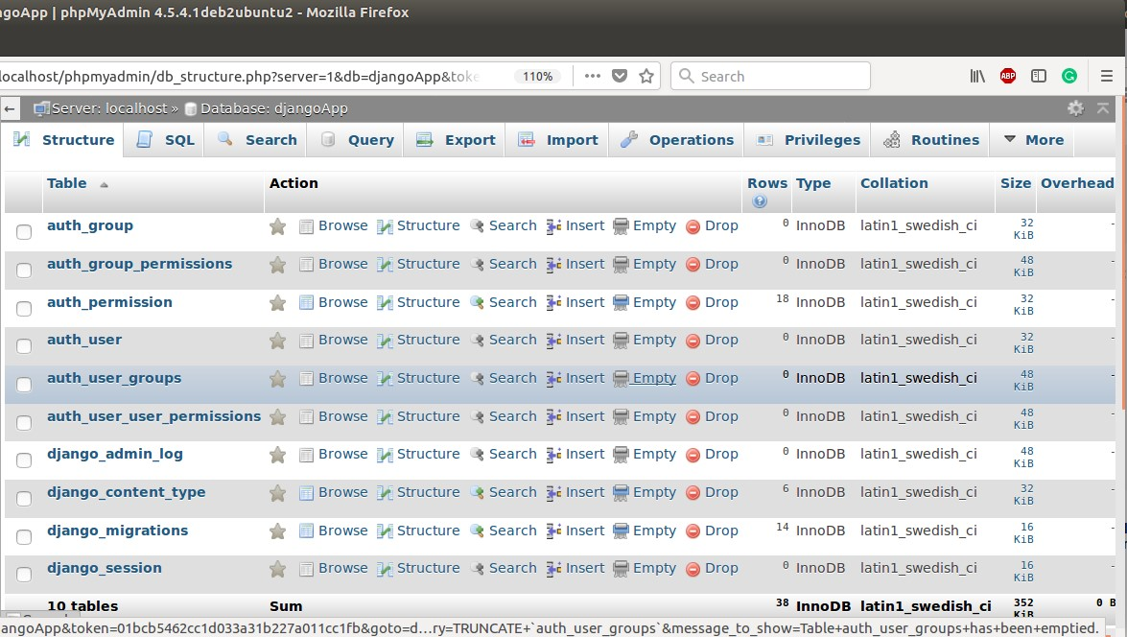

Figure 4.13: Database structure for the project.

#### Migrating Model

Well, till here, we have learned to connect Django application to the MySQL database. Next, we will see how to create a table using the model.

Each Django’s model is mapped to a table in the database. So after creating a model, we need to migrate it. Let’s see an example.

Suppose, we have a model class Employee in the models.py file that contains the following code.

Listing 4.42: models.py

|  |
| --- |
| from django.db import models class Employee(models.Model):  eid = models.CharField(max_length  =20) ename = models.CharField(max_length  =100) econtact = models.CharField(max_length  =15) class Meta: db_table = "employee" |

Django first creates a migration file that contains the details of table structure.

To create migration use the following command.

#### python manage.py makemigrations

The created migration file is located into migrations folder and contains the following code.

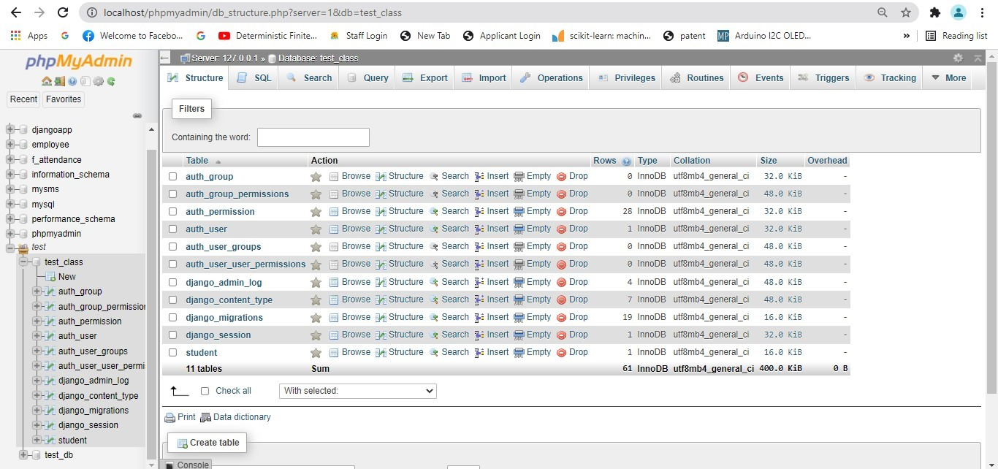

Figure 4.14: Database structure for the project includes the table.

from django.db import migrations, models class Migration(migrations.Migration):

initial = True

|  |
| --- |
| dependencies = [  ]  operations = [ migrations.CreateModel( name=’Employee’, fields=[  (’id’, models.AutoField(auto_created=True, primary_key= True, serialize=False, verbose_name=’ID’)),  (’eid’, models.CharField(max_length=20)),  (’ename’, models.CharField(max_length=100)),  (’econtact’, models.CharField(max_length=15)),  ], options={  ’db_table’: ’employee’,  }, ),  ] |

Now, migrate to reflect the changes into the database. Check the database again, now it contains the employee table.

See, a table is present in the database. Well, we have successfully established a connection between our Django application and MySQL database.

#### Django Default CRUD

Django provides an admin site to allow CRUD (Create Read Update Delete) operations on registered app model.

It is a built-in feature of Django that automatically generates interface for models.

We can see the url entry for admin in urls.py file, it is implicit and generated while creating a new project.

Listing 4.43: Url Setting in urls.py for admin

urlpatterns = [ path(’admin/’, admin.site.urls),

]

It can be easily accessed by after login from the admin panel, lets run the server python manage.py runserver and access it through the localhost:8000/admin.

A login form will be displayed, see the below.

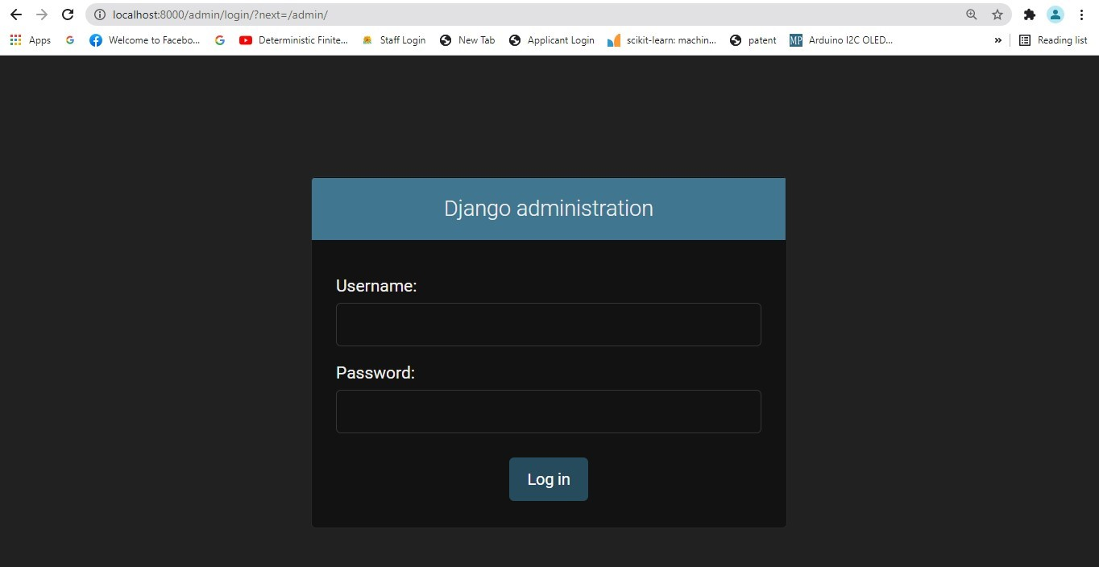

Figure 4.15: Admin login panel.

To login, first create admin (super user) user and provide password as we did here:

Listing 4.44: Url Setting in urls.py for admin

|  |
| --- |
| python manage.py createsuperuser  Username (leave blank to use ’ranjit’): c1 Email address:  Password (again):  This password is too common.  This password is entirely numeric.  Bypass password validation and create user anyway? [y/N ]: y  Superuser created successfully. |

Super user is created successfully, now login.

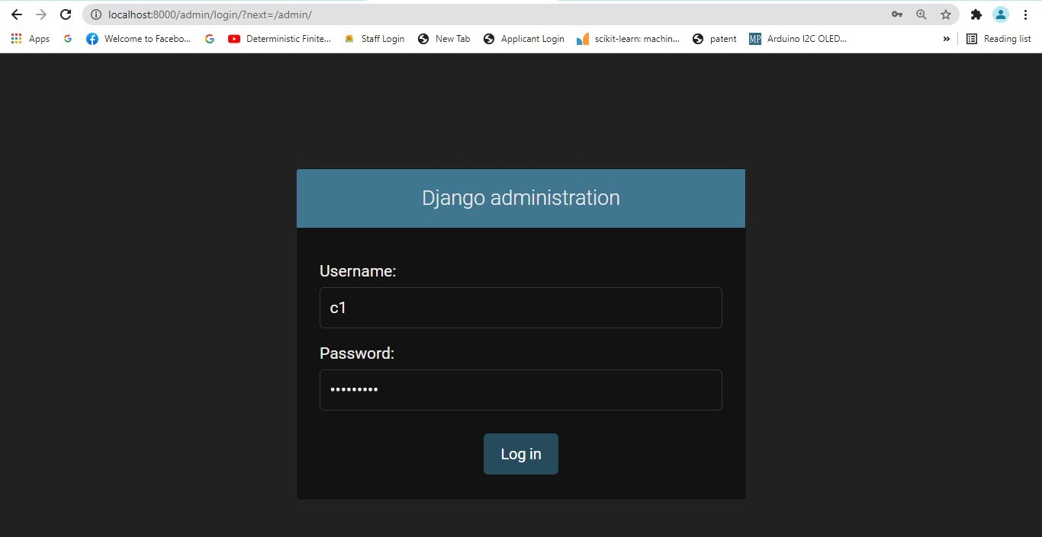

Figure 4.16: Admin login Credential.

It shows a home page after successfully login, see below.

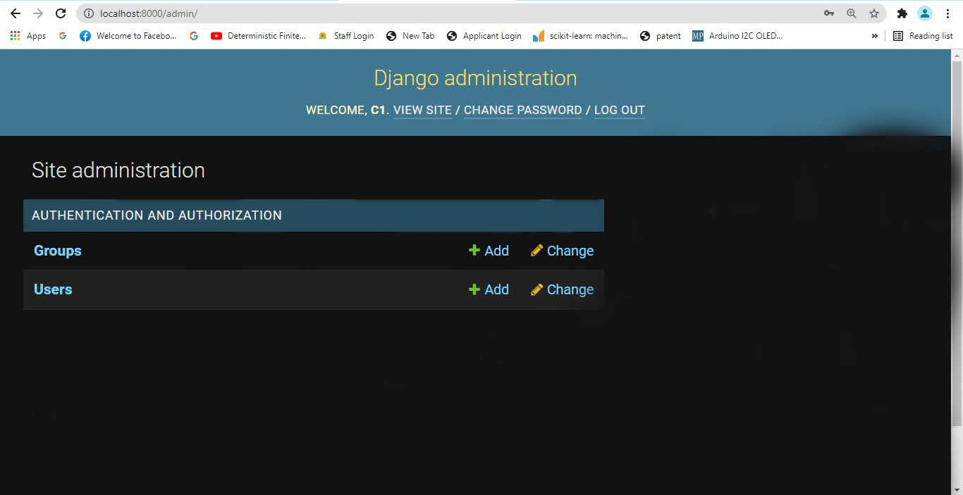

Figure 4.17: Admin Dashboard login.

It is an admin dashboard that provides facilities like: creating groups and users. It also used to manage the models.

#### Register Django Model

To register model in admin.py file. Use the admin.site.register() method and pass the Model name. See the example.

Listing 4.45: admin.py

from django.contrib import admin from app.models import Employee admin.site.register(Student) *# Student is registered*

Login again and see, it has employee object.

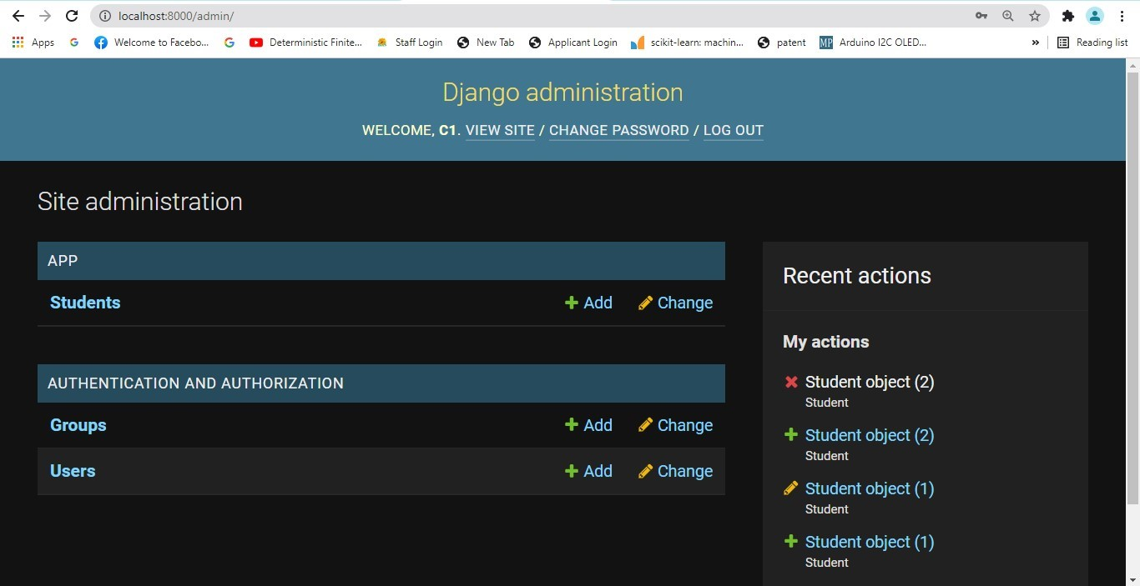

Figure 4.18: Admin login Dashboard after adding the table in the database.

It provides auto generated interface to create new model object. Like, if i click on add, it renders a form with all the attributes provided in the model class. For example, our model class contains the following code.

Listing 4.46: models.py

|  |
| --- |
| from django.db import models  *# Create your models here.* class Student(models.Model):  rollno = models.CharField( max_length=20)  sname = models.CharField(max_length =100)  Branch = models.CharField(max_length  =15) class Meta: db_table = "student" |

## 4.5 Data acquisition, Storage and Integration in IoT Framework

Data acquisition means acquiring the data from IOT/M2M devices. The data communicate after the interactions with a Data acquisition system (Application).The Application interacts and communicates with number of devices for acquiring the needed data. The devices send data on demand or at the programmed intervals. Data of devices communicate using the network, transport and security layers.

These acquired data is stored in the local or cloud system in the form of any file like: CSV or EXCEL or XML and in a database.

The stored data is displayed in the user interface or in an application through the internet. This process is called as data integration.

Here we considered an example of collecting data from temperature sensor and stored in the SQLite database.

Listing 4.47: Python Script for Temprature Monitor Application.

|  |
| --- |
| *#!/usr/bin/env python* import board import busio as io import adafruit_mlx90614 from time import sleep import sqlite3 from flask import * import time  app = Flask(__name__) *# Dfining App.*  con= sqlite3.connect("tempr.db") *# Database Connection Defining.*  @app.route("/") def home():  return render_template(’home.html’)  *#q1="create table temp(id INTEGER PRIMARY KEY*  *AUTOINCREMENT,reading text)"*  *#q3= "insert into temp(reading) values (?)"*  @app.route("/show")  *# Display Temptarure on Web Page from database.*  def show():  con = sqlite3.connect("tempr.db") con.row_factory = sqlite3.Row cur = con.cursor() cur.execute("select␣*␣from␣temp") rows = cur.fetchall() return render_template (’show.html’,rows = rows)  @app.route(’/fetch’) *# Inserting reading of temprature from sensor into Database.*  def fetch():  i2c = io.I2C(board.SCL, board.SDA, frequency =100000)  *# Sensor Pin Configuration.*  mlx = adafruit_mlx90614.MLX90614(i2c) |

|  |
| --- |
| *# Initializing Sensor.*  ambientTemp = "{:.2f}".format(mlx.  ambient_temperature)  targetTemp = "{:.2f}".format(mlx.object_temperature ) *# Reading body temprature from Sensor.* temp_far=(mlx.object_temperature*9 / 5) + 32 *# Converting from Celcius to Fahrenheit.*  *#q2= "select * from temp;"* temp= "{:.2f}".format(temp_far)  *# Display 2 digits after decimal point.*  con = sqlite3.connect("tempr.db") con.row_factory = sqlite3.Row cur = con.cursor() tim= time.localtime()  current_time = time.strftime("%H:%M:%S", tim) *# Record Timestamp.*  cur.execute("insert␣into␣temp(time,reading)␣values␣  (?,?)",(current_time,temp)) *# Insertin into table.* con.commit() msg="Data␣inserted" return render_template ("insert.html",msg=msg)  @app.route(’/show_temp’)  *# Showing current reading of temprature from sensor.*  def show_temp():  i2c = io.I2C(board.SCL, board.SDA, frequency  =100000) *# Sensor Pin Configuration* mlx = adafruit_mlx90614.MLX90614(i2c) *# Initializing Sensor.*  ambientTemp = "{:.2f}".format(mlx.  ambient_temperature)  targetTemp = "{:.2f}".format(mlx.object_temperature )  *# Reading body temprature from Sensor.*  temp_far=(mlx.object_temperature*9 / 5) + 32 *# Converting from Celcius to Fahrenheit.*  temp= "{:.2f}".format(temp_far)  *# Display 2 digits after decimal point.*  tim= time.localtime() current_time = time.strftime("%H:%M:%S", tim) c_time= str(current_time) res=temp + "degree␣F" + "␣Time␣of␣Measurment␣:␣" + c_time  return render_template(’temp.html’, result=res)  con.close()  if __name__=="__main__": app.run(debug = True) |

Listing 4.48: Home Page UI.

<!doctype html>

<html>

<title>Temprature</title>

<body>

<h1>Temprature Monitor System</h1>

<a href = "/fetch">Insert Temprature</a>

</br>

</br>

<a href = "/show">View Temprature</a>

</br>

</br>

<a href = "/show_temp">Display Temprature</a>

</body>

</html>

Listing 4.49: Storing Sensor data UI.

<!doctype html>

<html>

<title>Insert Temprature</title>

<body>

<h1> {{ msg }}</h1>

</br>

</br>

<a href="/">Go back to home page</a>

</body>

</html>

Listing 4.50: Fetch Temprature data from database UI.

|  |  |
| --- | --- |
| <!doctype html>  <html>  <title>Temprature</title>  <h3>Temperature Information</h3>  <table border=5>  <thead>  <td>ID</td>  <td>Time of Reading</td>  <td>Temperature</td>  </thead> | |
| {% for row in rows %}  <tr>  <td>{{row["id"]}}</td>  <td>{{row["time"]}}</td>  <td>{{row["reading"]}}</td>  </tr>  {% endfor %}  </table>  <br><br>  <a href="/">Go back to home page</a>  </body>  </html> | |

Listing 4.51: Showing Current temprature reading from sensor UI(Data Integration).

|  |
| --- |
| <!doctype html>  <html>  <title>Temprature</title>  <body>  <table>  <tr>  <td> Body Temprature is :</td>  <td> {{ result }} </td>  </tr>  </br>  </br>  <a href="/">Go back to home page</a>  </table>  </body>  </html> |

The above example is executed on Raspberry Pi 4 Model B and interfacing MXL90614 Touch-less Temperature Sensor.